**CATHOLIC UNIVERSITY OF EASTERN AFRICA**

**PROJECT REPORT FOR FINAL YEAR STUDY IN COMPUTER SCIENCE**

**BY**

**JANE WAMBUI KARUGA 1040477**

**ONLINE BAKERY MANAGEMENT SYSTEM**

**FEBRUARY 2024**

# DECLARATION

I, the undersigned, declare that this proposal is my original work and that it has not been presented in any other university or institution for academic credit.

Signature: …………………………. Date: …………………........

**Name: Jane Wambui Karuga**

**Registration Number:1040477**

Supervisor: This research proposal has been submitted for examination with my approval as University supervisor.

Signature: …………………………. Date: …………………........

**Mr. Michael Kinyua**

Head of Department: This research proposal has been submitted for examination with my approval as University supervisor.

Signature: …………………………. Date: …………………........

**Mr. Michael Kinyua**

**Head of Department Computer and Library and Information Science**

**Catholic University of Eastern Africa**

# ACKNOWLEDGMENT

I thank the Almighty God who gave me the opportunity and strength to pursue my studies to this end. My utmost gratitude goes to my supervisor, Mr. Michael Kinyua who has walked with me throughout my research project by giving me guidance which has been crucial for the successful completion of the project. I am also indebted to my classmates for encouraging me and assisting me with ideas where needed.

**DEDICATION**

This project is dedicated to my late grandmother, mother and siblings for their unlimited prayers, financial support and encouragement throughout my academic journey.

# ABSTRACT

*The bakery industry continues to be one of the fast rising industries in the food sector. However, the use of traditional paperwork to manage the systems causes these bakeries to have a reduced performance rate in terms of their sales since there is a slowdown in other related activities in the stores such as inventory management and in addition, the response time becomes lower especially when the store receives high traffic from the customers. For this reason, the research proposal aims to come up with an online bakery management system that aims to provide an efficient way for customers to order bakery products online and for inventory management for the managers of the bakery store. The research has some specific objectives guiding it such as to perform online ordering by the customers in terms of selecting their products and specifying customization, to keep track of inventory levels and facilitate order fulfilment. The system will follow several steps in the research design such as identifying requirements, collection of data through issuance of surveys, observations and document analysis, perform system designing, implementation and testing. The system is web based and shall be implemented using front end technologies that include HTML, CSS and JavaScript. The backend shall be implemented using PHP and data will be stored in a MySQL server. In addition, the PayPal API will be used in order to facilitate smooth payment of the products when purchased. The system will be of help to bakery owners, staff and their customers for carrying out a smooth business.*

Table of Contents

DECLARATION i

ABSTRACT ii

TERMS AND ABBREVIATIONS v

LIST OF FIGURES vii

CHAPTER ONE: INTRODUCTION 1

1.1: Introduction 1

1.2: Background of research 1

1.3: Problem Statement 2

1.4: Objectives of Research 2

1.4.1: General Objective of Research 2

1.4.2: Specific Objectives of Research 3

1:5: Justification of research 3

1.6: Scope of the project 4

1.7: Research Organization 5

CHAPTER TWO 6

REVIEW OF RELATED WORK 6

2.1: Introduction 6

2.2: Methodology of Literature Review 6

2.3: History of the Research Topic 6

2.4: Review of related Prototypes and Systems 7

2.4.1: BakeryBuddy, An Online Bakery Management System Prototype (Smith, J., & Patel, S. (2020)) 7

2.4.2: Web based prototype (Bhatti and Kamal (2019) 8

2.4.3: Local Bakery store in Nairobi, Kenya. 8

2.4.4: BakeSys, An Integrated Bakery Management System (Garcia, M., & Nguyen, T. (2010)) 9

2.4.5: Bakery Store in Nairobi, Kenya 10

2.5: Emerging trends and patterns in the research area 11

2.6: Research gap to be filled by your research 12

2:7: Chapter Summary 12

CHAPTER THREE 14

RESEARCH METHODOLOGY 14

3.1: Introduction 14

3.2: Methodology for Requirement Specification, Data Collection and Analysis Technique 14

3.2.1: Requirements Specifications 14

3:3:2: Data Collection Methods 15

3:3:3: Issuance of Surveys 15

3:3:4: Document Analysis 15

3:4: Methodology for System Analysis 15

3.5: Methodology for System Design 16

3:6: Methodology for System Implementation 16

3:6:1: Back End Technologies 16

3:6:2: Front End Technologies 16

3:6:3: Database Technologies 17

3:7: Methodology for System Testing 17

3:7:1: Testing Plan 17

3:7:2: Testing Techniques 18

3.8 Methodology for System Deployment 18

CHAPTER 4 19

SCHEDULE, BUDGET AND RESOURCES 19

4.1: Introduction 20

4.2: Project Schedule 20

4.3: Project Budget 20

4.4: Project Resources 21

APPENDICES 21

APPENDIX A: SAMPLE QUESTIONNAIRE 21

REFERENCES 25

# 

# TERMS AND ABBREVIATIONS

**Artificial Intelligence-**A method of making a computer, a computer controlled robot, or a software think intelligently like the human mind(SimplyLearn,2023)

**CAGR –**Compound Annual Growth Rate. This refers to a way of measuring the average annual growth rate of an investment over a period of time longer than one year.

**CSS (Cascading Style Sheets)**- style sheet language used for describing the presentation of a document written in a markup language such as HTML. It controls the layout, colors, fonts, and other visual aspects of web pages, allowing web developers to create visually appealing and consistent designs across multiple pages or even entire websites.

**DFD (Data Flow Diagrams)**- graphical representations used to illustrate the flow of data within a system. They depict the processes, data stores, data flows, and external entities involved in a system, showing how data moves through various components and processes.

**HTML (Hyper Text Markup Language)**- Standard markup language used for creating web pages and web applications. It defines the structure and content of a web page by using a series of tags and elements to indicate headings, paragraphs, images, links, and other elements.

**HTTP (Hypertext Transfer Protocol)** -A protocol used for transmitting hypertext documents over the internet. It facilitates communication between web browsers and servers by allowing clients to request resources and servers to respond with those resources.

**SQL (Structured Query Language)**- A specialized programming language used for managing and manipulating relational databases. It allows users to perform tasks such as querying data, inserting, updating, and deleting records, creating and modifying database schemas, and defining access controls.

**URL (Uniform Resource Locators)**: A URL is a reference or address used to locate resources on the internet. It specifies the protocol to be used for accessing the resource (such as HTTP or HTTPS), the domain name or IP address of the server hosting the resource, and the specific path or location of the resource on the server.

# LIST OF FIGURES

# CHAPTER ONE: INTRODUCTION

## 1.1: Introduction

This chapter provides an introduction to the bakery industry and justifies the need for an online bakery management system. It lays out detailed information on the background and motivation of the research, problem statement, defines the aims and objectives of the research, scope and in addition administers the justification of the research.

## 1.2: Background of research

Over the years, the bakery industry has proven to be one of the rising sectors when it comes to the food industry. According to a report by ResearchAndMarkets.com, the global bakery market is expected to reach $703.1 billion by 2027, growing at a CAGR of 3.8% from 2020 to 2027 (ResearchAndMarkets.com, 2020) This has been influenced majorly by the rising demand for healthy baked products and with low sugar content. For this reason, bakers have become more innovative when it comes to bakery products such as pastries and cakes. This has increased the production of customized baked goods according to the customer’s desires thus leading to better convenience to the customer. However, our local stores still face some challenges when it comes to this industry such as competition from larger bakery chains. Local bakeries face tough competition from larger bakery chains that have more resources and a wider reach. According to a study by IBISWorld, the top four players in the bakery industry account for over 45% of industry revenue (IBISWorld, 2021). This competition can make it difficult for local bakeries to attract and retain customers.

In addition to this, consumer preferences are constantly evolving, and local bakeries must keep up with the latest trends to remain relevant. For example, there has been a growing demand for gluten-free and vegan bakery products in recent years (Mintel, 2021). Local bakeries that fail to adapt to these changing preferences risk losing customers to competitors. Also, the cost of ingredients used in bakery products, such as flour and sugar, has been steadily increasing over the years. This can make it difficult for local bakeries to maintain profit margins while keeping prices affordable for customers. Technology on the other hand has continuously had a high trajectory growth in terms of how it has been embraced in our day to day lives and its continuous use across the globe by many different users. One of the most significant results of the technology growth is electronic commerce over the Internet, a new way of conducting business, otherwise known as e-commerce. It has made shopping of goods so much easier just with the tap of a button on your device hence no need to hustle with long queues at the physical stores.

The shift towards e-commerce has created a need for an efficient and effective e-bakery management system. Such a system would enable bakeries to manage their inventory, order processing, and delivery operations in real-time, allowing them to optimize their production and minimize waste. By automating various processes, such as order processing, inventory management, and production scheduling, bakery owners can save time, reduce errors, and improve productivity (Alalwan et al., 2017). Furthermore, the system can help reduce costs by optimizing inventory levels, minimizing waste, and improving supply chain management (Islam et al., 2017). Another benefit is improved customer service. With an e-bakery management system, customers can place orders online, track their orders, and receive notifications about their orders' status (Gao & Li, 2019). This convenience can enhance customer satisfaction and loyalty, leading to increased sales and revenue for the bakery.

## 1.3: Problem Statement

Numerous precise aspects play a role in running a bakery effectively, including order processing, customer service, and inventory control. However, the unique capabilities required to optimize operations in small-scale bakeries are often missing from current bakery management systems. Certain issues that these companies encounter like unpredictable ingredient availability, managing perishable inventory, and customized customer preferences cannot be sufficiently addressed by general management solutions. In addition, small bakeries usually use labor-intensive, prone to error manual methods for managing orders, tracking sales, and keeping track of inventories. This inefficiency affects profitability and customer happiness in addition to decreasing production.

## 1.4: Objectives of Research

## 1.4.1: General Objective of Research

The main objective of this research is to design and develop an Online Bakery Management System that will enhance customer outreach for small scale bakery businesses in Kenya.

## 1.4.2: Specific Objectives of Research

The research has some specific objectives that it aims in achieving at the end of the research. This includes the following:

1. To determine user requirements for the envisioned system.
2. To develop conceptual and technical designs based on the user requirements.
3. To implement the designed system using appropriate programming languages and technologies.
4. To execute testing procedures so as to identify and address any defects or discrepancies of the developed system.

## 1:5: Justification of research

There are many strong arguments in favor of the creation and application of an online bakery management system in Kenya, including societal, environmental, and economic ones.

Economic Justification: The economic landscape in Kenya presents challenges for traditional bakery businesses, particularly in the face of increasing costs and taxation. High taxes, such as value-added tax (VAT), impact the prices of goods and services, including bakery products. Consumers are continually seeking cost-effective options amidst these financial strains, driving the demand for online platforms where they can find affordable bakery products.

Environmental Concerns and Societal Shift towards Sustainability: There is a global trend towards sustainability in consumer behavior, with individuals increasingly prioritizing eco-friendly options in their purchasing decisions. This shift is evident in Deloitte's research, which highlights a growing awareness of environmental concerns among consumers. Additionally, Singh (2022) notes a significant shift towards eco-conscious choices, including the preference for pre-owned goods. This aligns with the development of an online bakery management system, which promotes the reduction of waste and encourages the reuse of bakery products.

Despite the economic challenges, the development of an online bakery management system in Kenya offers consumers a convenient and sustainable alternative to traditional bakeries. By providing a platform for online ordering and delivery, the system reduces the need for in-person transactions, thereby minimizing the environmental impact associated with transportation and packaging. Additionally, the system promotes the efficient use of resources by optimizing inventory management and reducing food waste.

In summary, the development of an online bakery management system in Kenya aligns with economic, environmental, and societal trends towards sustainability and offers consumers a convenient and cost-effective alternative to traditional bakeries.

## 

## 1.6: Scope of the project

The project scope entails the development of an online bakery management system customized to meet the operational needs bakery businesses in Kenya. Over a projected duration of six months and within a budget of 67,200 shillings, the system aims to streamline various aspects of bakery operations, including inventory management, order processing, and customer service.

Key functionalities of the system cover user roles for bakery owners and staff members. Bakery owners, as the primary stakeholders, require a comprehensive management solution to oversee their bakery operations effectively. Staff members, on the other hand, encompass employees tasked with specific bakery duties such as inventory monitoring, order fulfillment, and customer engagement.

The system's features include fast inventory management capabilities, allowing bakery owners and staff to monitor stock levels and track ingredient quantities. Additionally, order processing functionalities enable users to create and manage customer orders, track order statuses, and generate invoices for billing purposes.

Customer management functionalities are also integral, facilitating the maintenance of a customer database containing contact details and order history. This feature enables personalized communication and marketing efforts to enhance customer relationships.

Integration with local payment gateways, such as M-pesa, ensures secure online payment processing for customer orders. Additionally, the system enables online ordering through its platform, empowering customers to browse bakery products, specify delivery preferences, and complete transactions securely.

While the integration of the WhatsApp API for customer communication was initially considered, it has been omitted from the project scope. The assumption is made that customers can obtain the bakery's contact information from the website and initiate enquiries or place orders through traditional means, such as phone calls or in-person visits.

In essence, the proposed online bakery management system aims to offer bakery businesses in Kenya a user-friendly and efficient platform for optimizing operations and enhancing customer satisfaction.

## 1.7: Research Organization

This research has been broken own to detail into three chapters which is as follows:

Chapter One covers the Introductory part. It entails: Introduction of the research, background and motivation of the research, definition of the problem statement, the aim and objectives of the research, the justification and the scope of the project.

Chapter Two covers the Review of Related work. It entails Literature Review techniques, the study topic's historical background, a review of previous literature, systems that are now in place, prototypes, and developing trends and patterns in the field. It also briefly addresses research gaps that need to be filled in the field of study.

Chapter Three covers the Research Methodology to be used in the project. It entails: The methodologies to be used for Requirements Specifications, The System Analysis, Design, Implementation, Testing and Deployment of the project.

Chapter Four covers the scheduling, budgeting and resources that are needed for the project.

Chapter five details the system analysis of the current system, including its description, strengths, weaknesses, feasibility study, and data I/O analysis. It also presents the process logic design of the current system and summarizes the chapter's key points.

Chapter six focuses on the design of the proposed system, covering its description, strengths, weaknesses, requirement analysis, conceptual architecture, process logic design, and database design. It includes mock-up screens of the proposed system and concludes with a summary. Chapter seven presents the implementation and testing of the system, including system screenshots, testing plan, and evaluation plan. It summarizes the chapter's findings, challenges encountered, and offers future recommendations, concluding the report.

Chapter four outlines the project budget, schedule, and required resources, concluding with a summary of the chapter's contents.

Chapter five details the system analysis of the current system, including its description, strengths, weaknesses, feasibility study, and data I/O analysis. It also presents the process logic design of the current system and summarizes the chapter's key points. Chapter six focuses on the design of the proposed system, covering its description, strengths, weaknesses, requirement analysis, conceptual architecture, process logic design, and database design. It includes mock-up screens of the proposed system and concludes with a summary. Chapter seven presents the implementation and testing of the system, including system screenshots, testing plan, and evaluation plan. It summarizes the chapter's findings, challenges encountered, and offers future recommendations, concluding the report.

# CHAPTER TWO

# REVIEW OF RELATED WORK

## 2.1: Introduction

This chapter entails the studying and analyzing of previous works related to electronic bakery management system in regards to its history. In addition, related prototypes and emerging trends and patterns in the bakery management system industry are reviewed.

## 2.2: Methodology of Literature Review

For this research project, several methodologies were used to evaluate the earlier work done and assess the information that is accessible in the literature relevant to online bakery systems which includes the features, benefits, challenges and adoption rates that are associated with the system. Some of them include review of relevant journals, newspapers, publications and blogs, which have an aim of providing an overview of the current trends and best practices in the relevant scope. Potential search terms related to online bakery management systems can be used in conducting a search for relevant articles before screening and analyzing the literature. This may include: “Bakery Software”, “Digital bakery management” and “e-Bakery management”. This in turn can be used as guidelines in producing a seamless electronic bakery management system.

## 2.3: History of the Research Topic

The history of online bakery management systems can be traced back to the development of e-commerce and online ordering systems in the early 2000s. As more and more businesses began to establish an online presence, bakeries also started to explore the potential of e-commerce for their operations.

According to a study by Hu, Huang, and Fang (2018), the first online bakery management systems were developed in the mid-2000s, with the primary focus on online ordering and delivery tracking. These systems allowed customers to place orders online and track the progress of their orders, from the time of order placement to delivery. As technology continued to evolve, e-bakery management systems began to incorporate additional features and functionalities. For example, some systems included inventory management tools, allowing bakeries to track their inventory levels and manage their supplies more efficiently.

In the following years, online bakery management systems continued to evolve and become more sophisticated. By the mid-2000s, some systems were capable of managing a wide range of bakery operations, including inventory management, order processing, and customer relationship management (CRM). Today, there are a wide variety of e-bakery management systems available on the market, ranging from simple online ordering platforms to comprehensive enterprise resource planning (ERP) systems. These systems offer a range of features and functionality, allowing bakery businesses to choose the system that best meets their needs.

Overall, the history of online bakery management systems reflects the growing importance of technology in the bakery industry. As the industry has become increasingly competitive and customer expectations have risen, bakery businesses have turned to e-bakery management systems to help them stay ahead of the curve.

## 2.4: Review of related Prototypes and Systems

Various research projects have focused on online bakery management systems, resulting in the development of several prototypes and operational systems. This overview examines key studies and literature in the field, along with examples of systems that have been adopted in Kenya.

### 2.4.1: BakeryBuddy, An Online Bakery Management System Prototype (Smith, J., & Patel, S. (2020))

In their paper "BakeryBuddy: An Online Bakery Management System Prototype," Smith and Patel presented the system as a viable option for bakery owners looking to simplify their business processes. This prototype provides an intuitive interface designed to empower bakery owners to efficiently manage various aspects of their business, including orders, inventory, and customer relationships. With features like inventory tracking, sales analytics, and online ordering, BakeryBuddy shows that it can greatly improve bakery businesses' operational efficiency.

Even though BakeryBuddy provides excellent functionality, there is a significant research gap that needs to be addressed. While the system effectively addresses core operational requirements, it lacks integration with emerging technologies such as Artificial Intelligence (AI) and Internet of Things (IoT). Specifically, there's an absence of automated inventory management functionalities and predictive sales analysis capabilities leveraging AI and IoT advancements. This presents an opportunity for further research to explore the potential benefits and challenges associated with incorporating these technologies into online bakery management systems.

By addressing this research gap, future studies can look into the implications of integrating AI and IoT into BakeryBuddy and similar systems, aiming to enhance their capabilities and offer bakery owners enhanced tools for decision-making and operational optimization. Such investigations can pave the way for innovative solutions that leverage cutting-edge technologies to address the evolving needs of bakery businesses in an increasingly digital landscape.

### 2.4.2: Web based prototype (Bhatti and Kamal (2019)

In their 2019 study, Bhatti and Kamal presented a web-based prototype aimed at revolutionizing the online bakery management system landscape. This prototype is a significant advancement in the field because it incorporates important features like inventory management, transaction processing, and client relationship management. However, there is still a lack of research on how well the prototype addresses the complex issues faced by bakeries, even with its extensive feature set.

Specifically, the prototype's potential for tackling critical issues like perishable inventory management and personalized customer service remains underexplored. While it undoubtedly offers foundational functionalities, its capacity to provide tailored solutions to bakery-specific challenges warrants further investigation. By exploring these unknown areas, researchers can gain knowledge that advances the usefulness of the prototype and advances our knowledge of efficient bakery management in the digital age.

### 2.4.3: Local Bakery store in Nairobi, Kenya.

Established in 2011, this neighborhood bakery has transformed into an exceptional treat among the busy city of Nairobi, Kenya. This little yet booming bakery has not only won over the hearts of its local customers, but has also embraced the digital age by putting in place an online web-based bakery management system. This bakery has pushed itself into the digital space by using technology into its regular physical operations, providing its delicious pastries to a larger audience outside of its physical location.

The decision to implement a web-based online bakery management system has undoubtedly been instrumental in the bakery's success story. By leveraging this innovative solution, the bakery has streamlined its operations, from order processing to inventory management, and has provided its customers with a seamless and convenient ordering experience. The system has enabled customers to browse through an extensive selection of baked goods, place orders online, and even schedule deliveries, all from the comfort of their homes or offices.

Even so, there is a significant research gap that has surfaced despite the success and recognition this neighborhood bakery has received. Although the online platform provides convenience, customers can only select from a preset selection of flavors and designs that are available in-store. This limitation inhibits customers from expressing their unique preferences and desires, thereby potentially impacting their overall satisfaction with the ordering process. Indeed, the inability to showcase personalized cake designs or request specific flavor combinations may deter some customers from fully embracing the online ordering experience.

Addressing this research gap presents an opportunity for the bakery to further enhance its online presence and customer engagement strategies. By exploring ways to incorporate customization options into the online ordering platform, such as uploading photos of their desired cake or customizable flavor selections, the bakery can empower customers to create customized baked goods tailored to their preferences. Moreover, by acquiring feedback and actively listening to customer suggestions, the bakery can iteratively improve its online offerings and strengthen its competitive edge in the digital marketplace.

### 2.4.4: BakeSys, An Integrated Bakery Management System (Garcia, M., & Nguyen, T. (2010))

In 2010, Garcia and Nguyen introduced BakeSys, an integrated bakery management system aimed at revolutionizing bakery operations. This innovative system serves as a comprehensive solution for bakery management, facilitating order processing, inventory tracking, and sales analysis with ease and efficiency. Designed to cater to the diverse needs of both small-scale bakeries and large production facilities, BakeSys offers a user-friendly interface and adaptable functionality that streamlines bakery operations and enhances productivity.

Despite the commendable features and functionalities embedded within BakeSys, a notable research gap has emerged in the realm of user experience design for frontend interfaces. While the system excels in backend operations, there remains a need for further exploration of user-oriented design principles and usability testing methodologies to optimize the accessibility and usability of bakery management systems, particularly for non-technical users. This gap presents an opportunity for future research endeavors to delve deeper into the intricacies of frontend interface design, with a focus on enhancing user engagement, intuitiveness, and overall satisfaction with the system.

By addressing this research gap, researchers can contribute valuable insights towards the refinement and enhancement of BakeSys and similar bakery management systems. Through the exploration of user-centric design principles and rigorous usability testing methodologies, the accessibility and usability of these systems can be significantly improved, ultimately leading to greater user satisfaction and operational efficiency in bakery businesses. Moreover, by prioritizing user experience design in the development and implementation of bakery management systems, businesses can foster greater adoption and acceptance of these technologies among users of varying technical proficiencies.

### 2.4.5: Bakery Store in Nairobi, Kenya

In Nairobi, Kenya, a notable bakery store has emerged as a prominent player in the local market, showcasing the transformative power of adopting a web-based online bakery management system. When this bakery first opened its doors in 1997, it was just a small physical storefront. Over the years, it has grown significantly, becoming a successful online platform and increasing its physical presence. This strategic transition to an online bakery management system has not only enabled the bakery to reach a wider audience but has also facilitated the establishment of additional outlets, cementing its status as a fast-rising star in Kenya's bakery industry.

However, amidst the bakery's impressive journey of growth and expansion, a notable research gap has emerged. Despite the evident success of implementing an online bakery management system, there has been limited attention given to the impact of these systems on the overall customer experience. While the system has undoubtedly enhanced operational efficiency and facilitated business growth, there remains a need to explore how it has influenced customer satisfaction, engagement, and loyalty. This research gap offers a chance to look more closely at the complex relationships that exist between the dynamics of the customer experience and online bakery management systems.

By bridging the gap in research regarding the impact of online bakery management systems on the customer experience, stakeholders can make informed decisions to further optimize these systems and enhance customer satisfaction and loyalty. Moreover, a deeper understanding of customer dynamics in the context of online bakery operations can inform strategic initiatives to strengthen customer relationships, drive repeat business, and sustain long-term growth in the competitive bakery market.

Overall, research indicates that online bakery management systems can provide bakery businesses in Kenya with various benefits, including increased productivity, revenue, and operational efficiency. The examples and systems discussed demonstrate the potential for these systems to help bakeries overcome challenges in an increasingly competitive and technologically advanced market.

## 2.5: Emerging trends and patterns in the research area

In recent years, there has been a growing interest in the use of technology for e-bakery management systems. As the bakery industry becomes increasingly competitive and customer expectations rise, bakery businesses are looking for ways to improve their efficiency and enhance their customer experience. One of the major fast rising trends when it comes to the bakery industry is that of customers increasingly ordering bakery products online as a result of the rise of mobile apps and e-commerce platforms. According to (Ma et al., 2020), e-bakery management systems that provide online ordering and delivery capabilities can assist bakeries in acquiring new customers, increasing sales, and increasing customer loyalty.

Another emerging trend is the integration of artificial intelligence (AI) in online bakery management systems. AI can be used to optimize bakery operations such as inventory management, production planning, and quality control. For example, AI algorithms can analyze sales data to predict demand and optimize inventory levels, or they can monitor production processes to identify quality issues in real-time (Savchuk et al., 2021). This trend is likely to continue as AI technology becomes more accessible and affordable.

The growing application of data analytics in e-bakery management tools is another pattern that is emerging. Bakery companies now have access to a wealth of data on consumer behavior, production procedures, and supply chain operations thanks to the growth of digital platforms and Internet of Things(IoT) devices. This data can be used for data analytics to gain useful insights, such as finding patterns in consumer tastes, streamlining production, and enhancing supply chain effectiveness. (Gong et al., 2020).

Overall, these emerging trends and patterns are shaping the future of online bakery management systems, providing bakery businesses with new and innovative ways to improve their operations and provide value to their customers.

## 2.6: Research gap to be filled by your research

Despite the significant progress made in the development of e-bakery management systems, there are still several research gaps that need to be addressed. Some potential gaps to be filled may include:

Lack of studies that investigate the impact of e-bakery management systems on small and medium-sized bakeries. Most of the existing studies have focused on larger bakery chains, and there is limited research on how these systems can be adapted to the needs of smaller businesses. This is a critical gap since smaller bakeries may face different challenges and constraints in adopting e-bakery management systems, such as limited resources and technical expertise.

Another research gap is the limited attention given to the impact of e-bakery management systems on the customer experience. Although these systems can help bakeries improve their efficiency and reduce costs, their impact on the customer experience has not been fully explored. For example, how do these systems affect the speed and accuracy of order processing, the quality of products, and the overall satisfaction of customers? Answering these questions can help bakeries better understand the value of e-bakery management systems and improve their customer service.

A third research gap is the limited integration of e-bakery management systems with other technologies such as artificial intelligence (AI) and block chain. Although some studies have explored the potential of these technologies in the bakery industry, their integration with e-bakery management systems is still in its early stages. For example, how can AI be used to optimize production schedules and improve product quality? How can block chain be used to improve the traceability and transparency of the supply chain? Answering these questions can help bakeries unlock new opportunities for innovation and competitiveness.

In summary, there are several research gaps that need to be filled in the e-bakery management system area. Addressing these gaps can help bakeries better understand the potential of these systems, adapt them to their specific needs, and unlock new opportunities for innovation and competitiveness.

## 2:7: Chapter Summary

From this chapter, we have been able to get a clear understanding of related works from getting a perspective from its history, review of related works, review of related prototypes and systems, emerging trends and patterns in the area and lastly the research gaps that need to be filled in that area.

# CHAPTER THREE

# RESEARCH METHODOLOGY

## 3.1: Introduction

This chapter provides a comprehensive methodology review on Requirement specification, data collection and the system analysis, design, implementation, testing and deployment of the system.

## 3.2: Methodology for Requirement Specification, Data Collection and Analysis Technique

### 3.2.1: Requirements Specifications

The envisioned system will entail requirements that are to be imposed on its design and verification. These requirements include identification of the stakeholders who are the owner(s), employees, customers and suppliers for the ingredients.

In addition, the functional requirements for this system are highlighted as follows:

The system should have an ability to allow customers to place an online order (choose the size and add custom notes of the color designs they would like their cake to have decorated with), select delivery options and make a down payment securely.

The system should allow the bakery owner(s) to update the menu with ease, which includes adding, removing and modifying the products in the store depending on their availability and their prices.

The system, furthermore should be able to provide instantaneous information about the inventory level of ingredients, supplies and finished products.

The system should grant the bakery employees access to efficiently process and fulfill orders in terms of managing order queues, tracking order status and coordination of the delivery to the customer/pickup of the order.

The envisioned system also has non-functional requirements which are laid out as shown:

The system’s response time to order placement and payment procedure should be quick and can handle a large number of orders and transactions from customers without causing a slow down or in worst scenario crashing of the system.

The system should be user friendly and easy to use for all the stakeholders to navigate through and access the system.

The system must be available at all times with minimal maintenance delays.

The system ought to work with many different web browsers, operating systems and gadgets.

The system should be scalable in that it can handle increased traffic and additional features as the business grows.

### 3:3:2: Data Collection Methods

Several methods were used in the data collection process which include surveys and document analysis.

### 3:3:3: Issuance of Surveys

The researcher can create a one-minute online survey for the customers at the store to fill after purchasing a product on their feedback in regards to the speed of service, customer service satisfaction and overall satisfaction of the purchase process. The last section of the survey could have the customer express what they would like to be improved to make the store run better.

### 3:3:4: Document Analysis

The researcher can take a look at existing documentations of the store such as the sales, order history and customer feedback reports of the store within a certain timeframe. The use of these existing documents to the researcher is so that they may get a more detailed insight about the store in terms of the customer’s preferences, ordering trends and other important data points that may assist them in their analysis.

## 3:4: Methodology for System Analysis

System analysis is a structured process that involves examining and evaluating the components of a system and their interrelationships to identify opportunities for improvement or optimization (Bassil, 2015; Siau and Rossi, 2011). The purpose of this analysis is so that the researcher has a complete understanding of the requirements and can guarantee that the proposed system will be developed in accordance with those requirements. The components of the system need to be first identified and generate a conceptual model thereafter from the components for the purpose of determining how effectively each component works together to fulfill its function. For our case, we will be adopting the Object Oriented Analysis for the system.

## 3.5: Methodology for System Design

According to Hoffer, George and Valacich (2014), System Design is the process of specifying a detailed computer based solution for a business problem or opportunity. (Gheorge et al,.2017) indicates that system design ensures that the system is designed to operate efficiently, making it more reliable and stable. In this section, various processes for defining the architecture, product design, modules, interfaces, and data of the proposed system are discussed.

Object-oriented models will be utilized to design the proposed system, encapsulating data into reusable objects containing functions. To describe the relationships in the online bakery management system knowledge domain, entity-relationship diagrams (ERDs) will be employed. ERDs will provide valuable information to design a relational database that classifies, identifies interrelationships, and enforces referential integrities based on the proposed system.

## 3:6: Methodology for System Implementation

For the proposed system, it will be operational as a web based application whereby it can be accessed by any operational browser. In this section, in-depth details of the front end, back end and database technologies will be discussed for quality assurance purposes.

### 3:6:1: Back End Technologies

According to IBM, the backend is where the magic happens in a web application. It is the server-side of the application, where data is stored, processed, and served to the client-side. ("What is Backend? Definition and Examples," IBM, 2022). Our proposed system will be utilizing PHP as our backend technology. Its flexible ability to update and maintain the system over time, integrate with other applications and systems, reliability and security features make it the suitable backend technology to utilize during the project. It will be responsible for storage and management of data used by the system as well as facilitate the processing of requests from the front end and communicating with other systems that are integrated to the bakery system such as payment gateways. In addition, the business logic of the system will be implemented here in instances such as tracking of payments and orders, addition and deletion of products in the system

### 3:6:2: Front End Technologies

The envisioned system will make use of front end technologies such as HTML, CSS and JavaScript. The users who are the customers in our case will be presented upon firstly the eye-catching Home page made by mostly HTML and CSS for the designing. It will contain an overview about the company, Login/Register, Contact Us and the Order pages respectively. Before a user makes an order, they will be prompted to create a new account if they are new or login if they are regular customers through a pop up window. All new users’ details will be captured by filling a form created by HTML which will contain personal details such as the customer’s names, age, phone number and area of residence. Validation of the user’s details will then be implemented by the use of JavaScript. The order section will then allow the user to customize what they would like to have to their preference through a drop down menu. Uniform Resource Locators (URLs) will also be used in our application for navigation purposes through the different web pages and for social media sharing purposes.

### 3:6:3: Database Technologies

Our system will utilize a relational database which stores data in tables with each table representing a different type of data such as inventories, sales, customers or employees. The management system to be used will be MySQL and the language to be used to query in the database will be Structured Query Language(SQL).

## 3:7: Methodology for System Testing

System testing is a major stage when developing an e bakery management system as it certifies that the application under test(AUT) meets the client’s expectation. Various testing methodologies shall be used to validate the application under test which majorly include functional and non-functional testing. However, a test strategy is in need beforehand so as to cater for the estimations and resources and create a schedule for when each testing will take place. For this, a test plan is created to act as a blueprint of how the testing will take place.

### 3:7:1: Testing Plan

The test plan is a dynamic document that acts as a blueprint of how the testing activity is going to take place in the project. It will have specific objectives of ensuring the bakery management system meets the functional and non-functional requirements, validate the system’s performance, reliability and security, verify the usability and accessibility of the system and lastly identify and document any defects found during the testing process. The various requirements to perform the testing for instance the hardware and software requirements, test data and resources, tools and technologies and the test environment setup need to be noted down in the test plan so that the testing activity may be successful.

### 3:7:2: Testing Techniques

Various techniques will be used to test the application under test against the functional or non-functional requirements gathered from business. For functional requirements, Unit testing, which is the first level of testing will be performed by the developer to ensure everything is running smoothly. Integration testing can then be used to determine whether the system's components are interacting in such a way that there is no contradiction between the system's functionality and the requirements listed in the requirements document. The researcher can also conduct system testing to confirm that the complete system is operating as intended and satisfies the set criteria. The system's suitability for the user's requirements must also be confirmed through acceptance system testing.

For non-functional requirements, performance testing can be undertaken to test how much time it takes to process an order after ordering under different scenarios. Usability test can also be performed to check if the system is user friendly for all stakeholders, including those with no technical background. Each of these techniques are performed so as to find a specific kind of defect.

## 3.8 Methodology for System Deployment

System deployment involves the processes used to plan for and manage the transition of new or evolved systems and capabilities into operational use and the transition of support responsibilities to the eventual maintenance or support organization. All of the procedures, actions, and processes necessary to make a software system or upgrade accessible to its intended users are included in software deployment. One software release will contain all of the resources and code that have been collected. The system will be deployed to a server following testing. Either a local computer or the cloud can host the system. The system will be deployed on the cloud since it is a web-based application. The tools to be utilized for local server development will be Apache server .The code will also be stored in a GitHub repository.

## 3:9: Chapter Summary

This chapter has descriptively been able to bring out the requirements specifications of the system, the various data collection methods to be used for analysis and the methodologies utilized right from the analysis all the way through till the deployment stage.

# 

# 

**CHAPTER 4: SYSTEM ANALYSIS**

**4.1: Chapter Introduction**

This chapter's examination focuses on analyzing the online bakery management system's present condition and identifying its advantages and disadvantages. To ascertain the viability of the suggested new system and identify the crucial conditions for its execution, a feasibility study is carried out. A brief summary outlining the most significant findings drawn from the analysis closes the chapter.

**4.2: Description of the Current System**

The current system operates on a web-based platform. Customers interested in purchasing bakery goods initiate the process by contacting the bakery through the website, providing details about the items they wish to buy, and arranging payment directly with the bakery outside the website. Once payment is confirmed, the bakery posts the items on the website for potential buyers. Each listing includes a description of the bakery goods and the bakery’s contact information for direct communication between customers and the bakery.

**4.2.4: Strengths**

The key strengths of the web-based online bakery management system include the following:

Web-Based User-Friendly Platform: Customers who want to browse and buy bakery goods can do so with ease and convenience thanks to the system's hosting on a dedicated website.

Effective Inventory Control: As orders are submitted, the system automatically keeps track of and deducts materials from inventory, guaranteeing correct stock management and lowering the possibility of ingredient shortages.

Commonly Recommended Flavors: By providing individualized recommendations, the technology improves the customer experience by recommending popular flavors based on user preferences and past orders.

Optimized Order Fulfillment: Order administration and processing are made simple by the admin panel, which boosts operational effectiveness and guarantees that customer orders are fulfilled on time.

Flexibility for Custom Orders: Through the internet, customers can simply place custom orders, allowing for greater personalization and satisfying unique demands.

**4.2.5: Weaknesses**

Inaccurate Inventory Tracking: The system may not accurately reflect real-time stock levels, leading to discrepancies between digital records and physical inventory. This could result in potential overselling or stock outs on busy days.

Limited Custom Order Validation: The customization feature may lack proper validation checks for feasible options. This could result in orders that are difficult or impossible to fulfill, leading to customer disappointment and operational inefficiencies.

Complex Pricing Logic: The system may struggle to correctly apply various pricing rules, discounts, or surcharges, particularly for orders with multiple items or customizations. This can lead to pricing errors and customer dissatisfaction.

Order Specification Clarity: The system may lack the ability to clearly communicate complex customizations to bakery staff, increasing the risk of errors in order fulfillment.

## 4.3: Feasibility Study & Its Conclusion

This section assesses the feasibility of implementing the proposed online bakery management system. The feasibility study includes an analysis of technical, operational, economic, market, and operational aspects. The conclusion of the feasibility study will inform the researcher about the viability of the project and whether it should proceed.

### 4.3.1 Project Description

The project aims to develop a user-friendly web-based platform for managing bakery operations. Its goals include providing a seamless online experience for customers to browse and purchase bakery items, including pre-set options and custom orders. The platform will focus on affordability and convenience to address the needs of local customers. It will also offer features tailored to the specific requirements of the bakery market, ensuring a user-friendly interface for both customers and bakery staff.

### 4.3.2 Economic Feasibility

The current economic landscape involves various challenges such as high operational costs and fluctuating ingredient prices. The proposed system adopts a web-based model that streamlines bakery operations, potentially reducing overhead costs by minimizing manual processes and optimizing inventory management. The platform aims to enhance cost efficiency by automating order processing, inventory tracking, and financial transactions. This approach not only offers cost-effective solutions for managing bakery operations but also provides customers with affordable bakery products, contributing to overall financial sustainability.

### 4.3.3 Market Analysis

The market for online bakery services is growing, with increasing consumer preference for convenient online shopping options. Existing trends show a significant demand for user-friendly web platforms that allow customers to easily browse and purchase bakery goods. A review of current online bakery solutions indicates a gap in comprehensive, user-centered systems that cater to both pre-set and custom orders. Consequently, the target market for the proposed system includes consumers seeking a streamlined, efficient way to purchase bakery items online.

### 4.3.4 Technical Feasibility

The technical feasibility of the proposed online bakery management system is supported by a robust technological foundation. Front-end development utilizes HTML, CSS, and JavaScript to create an engaging and interactive user interface. Back-end development employs PHP for dynamic content generation and effective communication with a MySQL database, which stores crucial data such as user information, product listings, and transactions. Integration of secure payment gateways ensures safe and efficient financial transactions, while automated inventory management features enable real-time tracking of ingredients and stock levels. This comprehensive technical approach ensures that the system is scalable, secure, and capable of providing an optimal user experience.

### 4.3.5 Operational Feasibility

**User Acceptance:**

User acceptance is critical for the success of the online bakery management system. To gauge willingness and readiness, extensive user surveys, interviews, and usability testing will be conducted. Insights into user preferences, expectations, and potential challenges will inform the design and functionality of the platform, ensuring it aligns closely with user needs and enhances overall satisfaction.

**Impact on Operations:**

The impact on current bakery operations will be thoroughly analyzed to identify potential disruptions or improvements. This includes evaluating how the new system will affect order processing, inventory management, and customer interactions. Proactive adjustments will be made to ensure a smooth transition, with effective communication strategies implemented to minimize any disruptions during the integration of the new system into existing workflows.

### 4.3.5 Conclusion

The feasibility study concludes that the proposed online bakery management system is viable and should proceed. The system effectively addresses operational challenges, provides a user-friendly and cost-effective solution for managing bakery operations, and strategically positions itself within the market. With a focus on seamless online transactions, inventory management, and customer engagement, the platform is well-equipped to meet the needs of both the bakery and its customers. Its robust technical foundation and operational design ensure that it will enhance efficiency and user satisfaction, making it a valuable addition to the bakery’s operations.

# 4.4 Data I/O Analysis - Data Captured by the Current System, Relationship Between the Data, Outputs from the System

This section provides an analysis of the data input and output processes within the current online bakery management system. The platform facilitates the ordering and management of bakery goods through a series of interactions between customers, bakery staff, and the web-based system.

### 4.4.1 Data Capture

Customers initiate the ordering process by logging into the web-based platform and browsing the bakery’s offerings. They provide detailed information about their orders, including product selections, quantities, and any custom requirements. This initial interaction establishes a direct one-to-one relationship between the customer and the system, facilitating effective data capture and order processing.

### 4.4.2 Data Relationships

Each order placed by a customer creates a distinct record within the system, forming a one-to-one relationship between the customer and their order. Within the order record, multiple items can be included, establishing a one-to-many relationship between the order and the items. Additionally, the system tracks relationships between orders and inventory, ensuring that ingredient levels are updated accordingly.

### 4.4.3 Data Processing

Once an order is confirmed and payment is processed, the system updates inventory levels by deducting the necessary ingredients. This transactional data is processed to confirm the order’s status and prepare it for fulfillment. Payment confirmation serves as a critical trigger point, indicating that the order is ready for preparation and subsequent delivery or pickup.

### 4.4.4 Outputs

After the order is processed, the system generates outputs that include order confirmations and receipts sent to customers. Additionally, the bakery staff receives order details through the admin panel, enabling them to manage and fulfill orders efficiently. These outputs ensure that both customers and staff are informed about order status and relevant details.

### 4.4.5 User Interactions

Customers interact with the platform through various actions, including browsing products, adding items to their cart, and completing purchases. They may also provide feedback or communicate directly with bakery staff via integrated messaging features. These interactions enhance user engagement and support efficient communication between customers and the bakery.

### 4.4.6 Data Updates

As orders are processed, the system updates inventory levels and order statuses to reflect the most current information. When an item is sold, the system automatically updates the inventory and changes the order status to "completed." This update process ensures that the availability of items is accurately reflected on the platform. Additionally, customers receive updated order confirmations and notifications about the status of their purchases.

In summary, the data flow within the online bakery management system revolves around a structured process initiated by customer orders and managed by the system. Customers provide detailed order information through the platform, establishing a clear line of communication with the system. Upon confirmation of payment, the system updates inventory and order statuses, ensuring accurate tracking and fulfillment of orders. Proactive updates and notifications maintain transparency and keep all parties informed about the status of transactions, enhancing the overall efficiency and user experience of the platform.

# 4.5 Process Logic Design of the Current System

This section focuses on the design of the existing online bakery management system, illustrated using use case diagrams. These diagrams represent how data flows and processes work within the system, helping to understand the system's architecture and interactions between different components. The design outlines the sequence of operations from customer interactions to order fulfillment, detailing how the system manages data inputs, processes transactions, and generates outputs. This visualization aids in comprehending the functionality and efficiency of the system, providing insight into its operational dynamics.

### 4.5.1: Use Case Diagram

### 4.5.2 System Users/Actors, Inputs, and Outputs

## System Users/Actors

## **Owners**

Manage the online bakery system, including overseeing daily operations, updating inventory, managing orders, and handling customer interactions. They have administrative privileges to access and control various aspects of the system.

**ii)Administrator**

A role within the bakery ownership responsible for specific administrative tasks such as processing orders, updating item listings, and generating reports.

## Customers

**Guests**

Visitors who access the platform without creating an account. They can browse items and get an overview of the bakery’s offerings.

**New Customers**

Create an account to access the platform's full features. This involves a registration process to establish a user profile.

**Existing Customers**:

Have previously created accounts and can log in to access their profiles, place orders, and track their purchases.

## System Inputs and Outputs

**Inputs**

## i)User Registration Form

Captures details for new customer accounts, including personal information and login credentials.

## ii)Item Listing Form

Used by the admin to input details about bakery items, such as descriptions, images, and prices.

## iii)Search Criteria

Allows customers to filter and search for bakery items based on attributes like category, price, and popularity.

iv)Payment Details Form

Collects payment information from customers for processing transactions.

# Outputs

**i)Item Listing Details**

Displays detailed information about bakery items, including descriptions, images, prices, and availability.

**ii)Order Confirmation**

Sent to customers after an order is placed, confirming the details of their purchase.

**iii)Order Status Updates**

Provides customers with updates on the status of their orders (e.g., processing, shipped, completed).

**Inventory Reports**

Generated by the admin to monitor and manage stock levels of bakery items.

**Sales Reports**

Summarizes sales data, including total sales, popular items, and revenue, aiding the admin in business analysis.

# 4.6 Chapter Summary

The chapter provides a detailed examination of the online bakery management system. It starts by introducing the system and its key functionalities. A feasibility study confirms the system's potential and areas for improvement. A Data I/O analysis explores the data captured, its relationships, and the outputs generated by the system. The chapter concludes with a process logic design, illustrated with diagrams, to illustrate how data flows and processes work within the system.

# CHAPTER 5: SYSTEM DESIGN

## 5.1 Introduction

This chapter provides a thorough description of the system design for the proposed online bakery management system. It delves into the critical components necessary to create a robust and efficient application that meets the identified goals and objectives, ensuring a seamless experience for both customers and bakery owners.

## 5.2 Description of the Proposed System

The proposed online bakery management system is designed to enhance the bakery shopping experience by offering a user-friendly platform for customers to browse, order, and manage bakery items. The system aims to streamline the purchasing process and improve inventory management, benefiting both bakery owners and customers.

### 5.2.1 Strengths of the Proposed System

### i) Enhanced User Experience

The system provides a direct purchasing model that allows customers to easily browse and order bakery items online. By removing intermediaries, the system offers a more straightforward and transparent transaction process, improving the overall user experience.

**ii) Efficient Inventory Management**

The system enables bakery owners to manage their inventory effectively, track ingredient usage, and update stock levels in real time. This efficiency helps maintain optimal inventory levels and reduce wastage.

**iii) Customer Engagement and Loyalty**

The integration of features like loyalty points and personalized recommendations enhances customer engagement. Customers are rewarded for repeat business, which fosters loyalty and encourages them to return to the bakery.

**iv) Custom Orders**

The system allows customers to place custom orders, providing flexibility for unique or personalized bakery items. This feature caters to individual preferences and special requests, increasing customer satisfaction.

**v) Transparency and Reliability**

The system ensures transparency in transactions and order processing. Real-time updates on order status and inventory levels build trust and confidence among users, contributing to a reliable and efficient bakery management process.

### 5.2.2 Weaknesses of the Proposed System

**i) Dependence on Technology**

The system's reliance on technology for order processing and inventory management may pose challenges if technical issues arise. Ensuring system reliability and robustness is crucial to minimize disruptions.

**ii) Data Security Concerns**

With the integration of online payments and customer data management, robust data security measures are essential to protect sensitive information. Implementing effective data protection strategies is necessary to safeguard customer data and maintain system integrity.

## 5.3 Conceptual Architecture of the Proposed System

The conceptual architecture of the online bakery management system is designed to ensure seamless operation and integration of various components. It includes the following layers:

## User Interface Layer

The user interface is the primary interaction point for customers and bakery owners. It includes a web-based platform that allows users to browse bakery items, place orders, and manage their accounts. Features for custom orders and inventory management are also accessible through this interface.

## Application Logic Tier

This layer handles the core business logic of the system, including order processing, inventory management, and user authentication. It ensures that transactions are processed correctly, orders are managed efficiently, and customer interactions are handled smoothly.

## Data Management Tier

This layer is responsible for managing and organizing data within the system. It includes an Entity-Relationship Diagram (ERD) that outlines the relationships between data entities such as bakery items, customer profiles, and order histories. Data integrity, consistency, and security are maintained through this layer.

Communication between these layers is managed through secure protocols, such as HTTPS, to protect data transmitted between users and the server. Industry-standard APIs facilitate integration with external systems and services, ensuring a cohesive and interconnected bakery management environment.

## 5:4 Process Design

The process design of the online bakery management system outlines the systematic flow of activities within the system, aiming to enhance efficiency and provide a clear understanding of its functionalities. The design follows Object-Oriented Systems Analysis and Design (OOSAD) methodology to ensure a well-structured system.

Upon accessing the online bakery management system, users start with a login process that verifies their credentials against the database. Successful login directs users to their respective dashboards based on their roles:

Bakery Owners/Admin: Access a dashboard for managing inventory, updating product listings, and processing orders. They can add new bakery items, monitor stock levels, and view order histories. This involves writing new data to the database and retrieving information for inventory management and order processing.

Customers: Access a product catalog to browse and search for bakery items. They can view detailed product information, add items to their shopping cart, and proceed to checkout. The system retrieves cart contents from the database, calculates the total cost, and processes the payment. Upon successful payment, order details are updated in the database, and inventory records are adjusted accordingly.

This systematic approach ensures that all interactions are managed efficiently, providing a seamless and user-friendly experience for both bakery owners and customers.

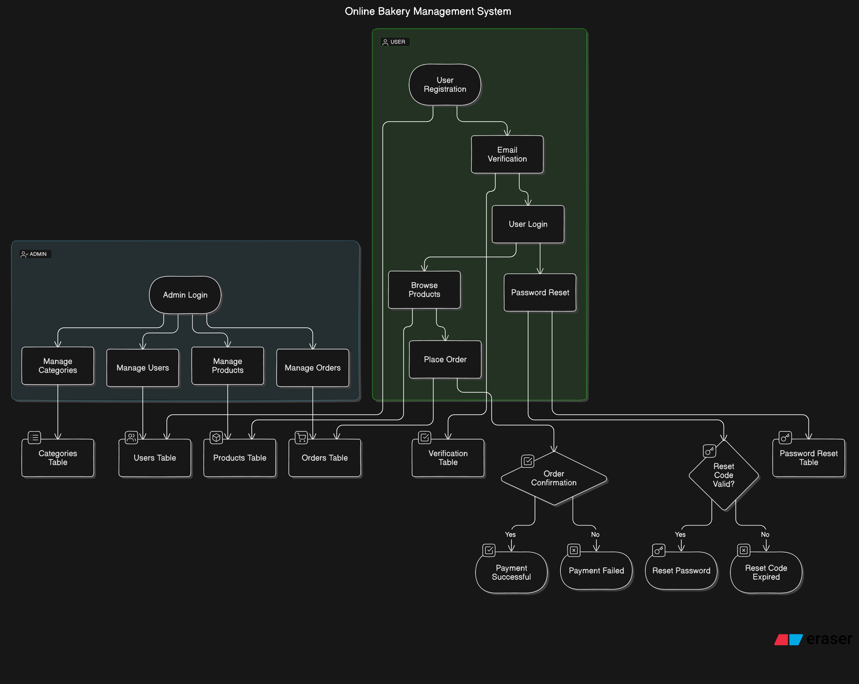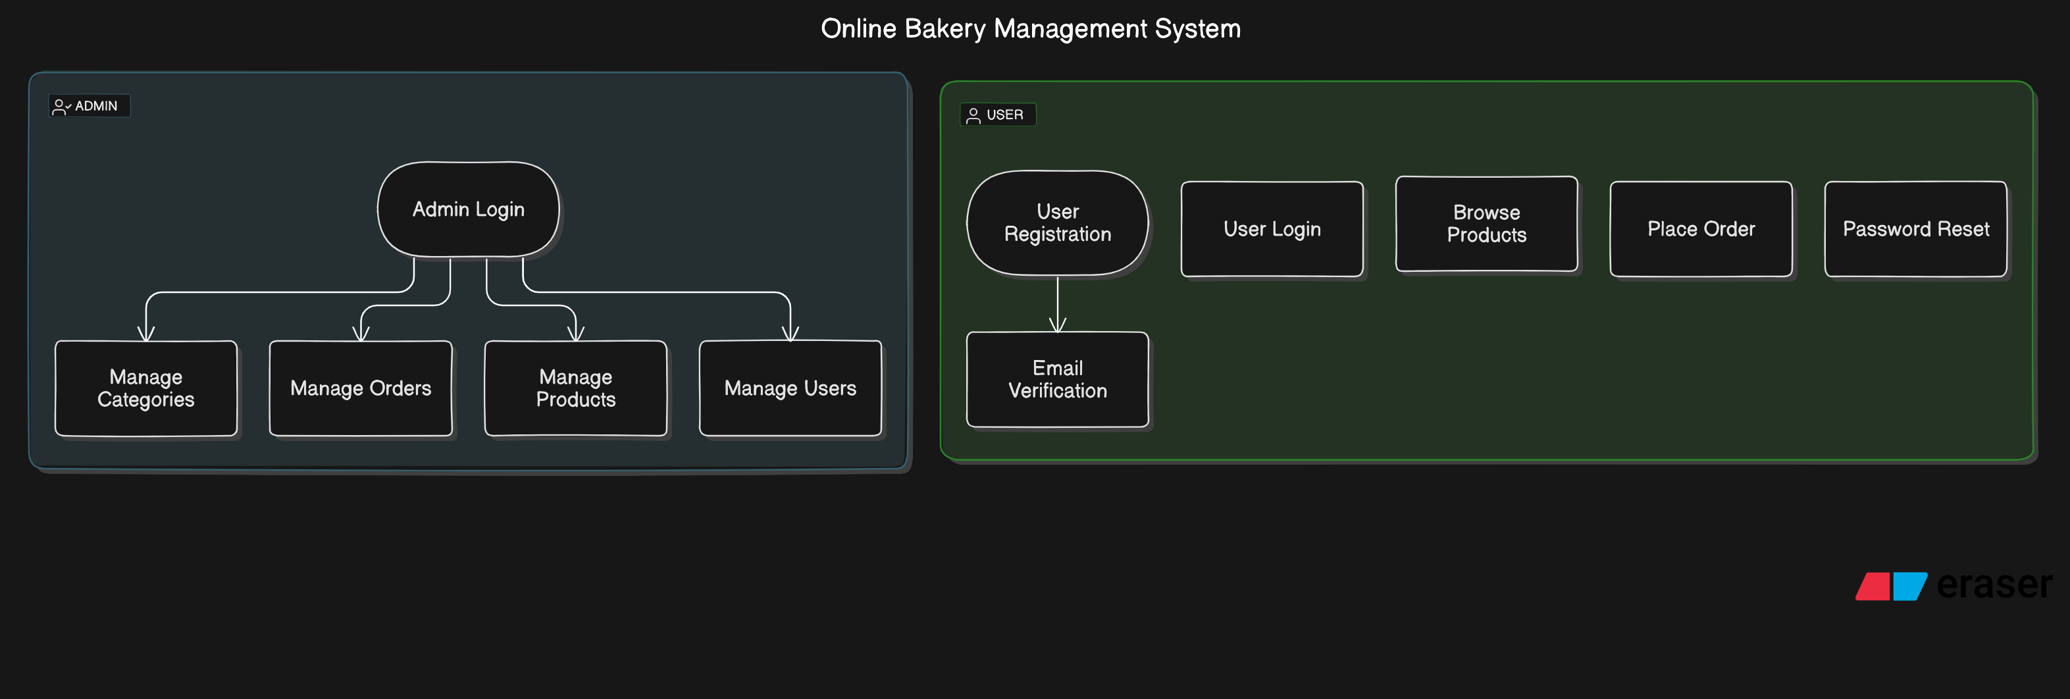

### 5.4.1 Activity Diagram

The activity diagram for the online bakery management system illustrates the sequence of activities and the flow of control between different actions within the system. This visual representation helps in understanding how users interact with the system based on their roles, including customers, bakery owners/admins, and the system overall. The diagram includes the following key activities:

## Customer Activities:

Browse Bakery Items: Customers view available bakery items on the website.

Search for Products: Customers use search criteria to find specific bakery items.

Add Items to Cart: Customers select and add desired items to their shopping cart.

Checkout: Customers review their cart, provide payment details, and complete the purchase.

Receive Order Confirmation: Customers receive confirmation of their order and expected delivery details.

## Bakery Owner/Admin Activities:

Login to Admin Panel: Owners/admins log in to access their management dashboard.

Manage Inventory: Owners/admins update inventory levels, add new items, and adjust stock.

Process Orders: Owners/admins review incoming orders, update order status, and handle fulfillment.

Generate Reports: Owners/admins generate reports on sales, inventory, and customer data.

## System Activities

Authenticate Users: The system verifies user credentials during login.

Update Inventory: The system automatically adjusts inventory levels based on orders.

Process Payments: The system handles payment transactions and updates order status upon successful payment.

Send Notifications: The system sends order confirmations and status updates to customers.

This diagram provides a clear overview of the order of activities within the online bakery management system, highlighting the interactions between different user roles and system processes.

## 5.4.2 Diagram of a use case

The interactions between the system's main players—clients, dealers, and the manager—are depicted in the use case diagram. It highlights features that are important to users, like browsing, buying, and uploading books. This helps the development team match system features to user needs (Fernandes, 2022).

## 5.4.2 Sequence Diagram

The retailing project's sequence diagram shows how different actors—such as customers, dealers, and managers—interact in detail with system elements to accomplish particular functionalities. It highlights the dynamic behavior of the system by giving a visual depiction of the messages that are exchanged.

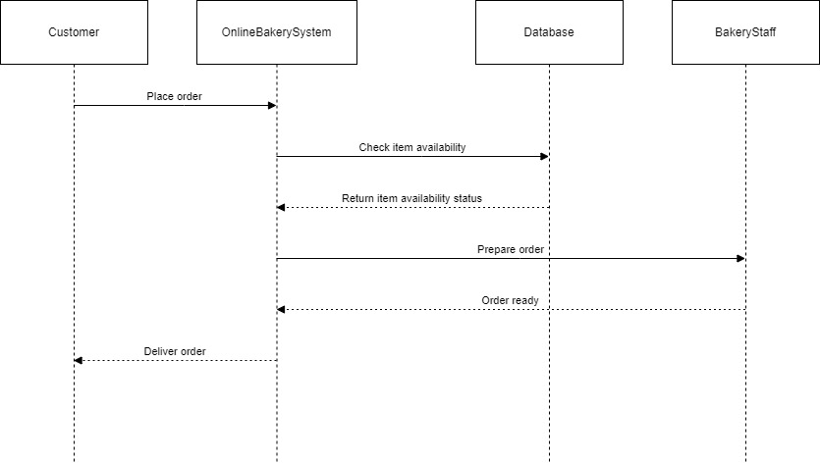

Figure 5.4.2: Sequence Diagram for proposed system(Author,2024)

## 5.5 Database Design

### 5.5.1 Entity-Relationship Diagram (ERD)

The Entity-Relationship Diagram (ERD) for the bakery management system provides a visual representation of the relationships between various entities within the database. This diagram is essential for understanding how different data components are interconnected, ensuring that the database is designed efficiently to handle the operations necessary for managing the bakery's day-to-day activities.

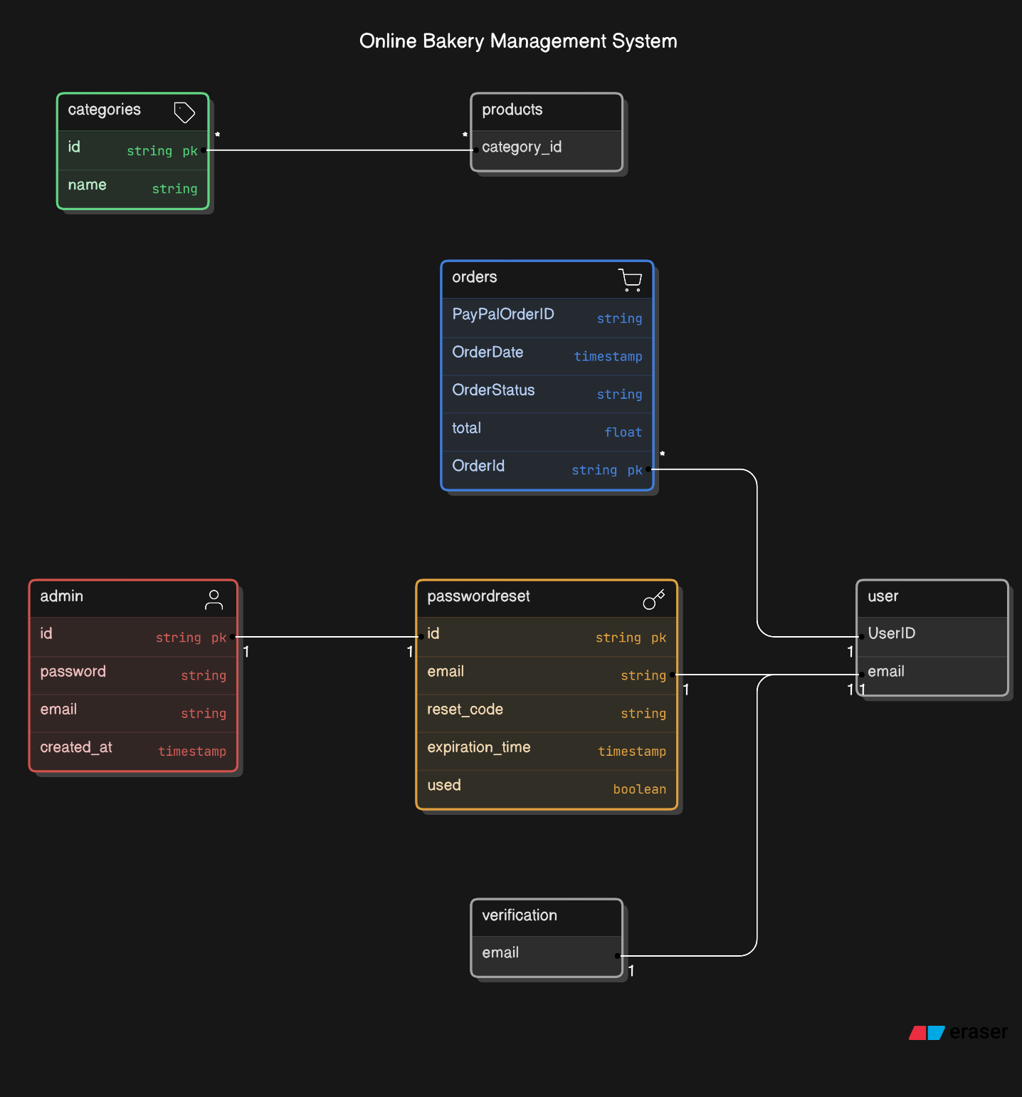

### 5.5.2 Data Dictionary

The Data Dictionary for the bakery management system serves as a comprehensive guide that details the definitions, attributes, and relationships of each data entity within the database. It includes descriptions of tables, fields, data types, constraints, and relationships, providing a standardized reference for understanding the database structure. This document is essential for ensuring efficient data management, retrieval, and maintenance within the system.

### 5.5.2.1 Users Table

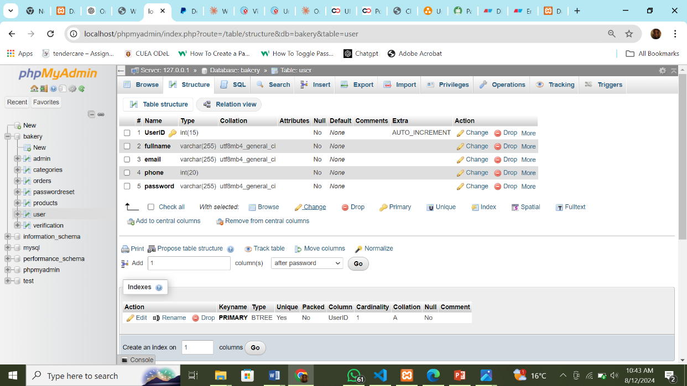

Figure 5.7: Users Table

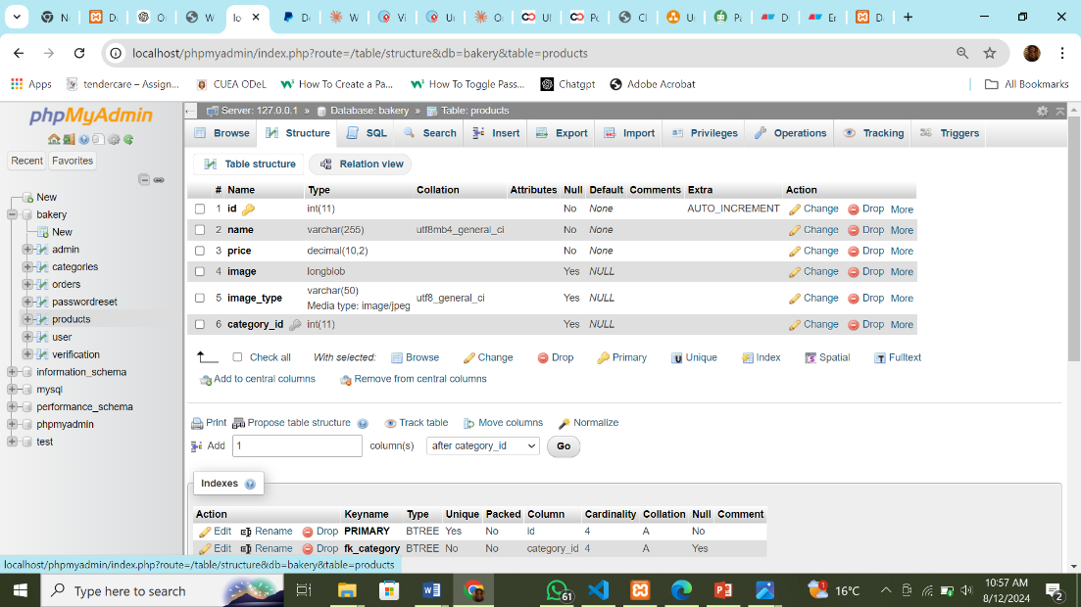

Figure 5.8: Products Table

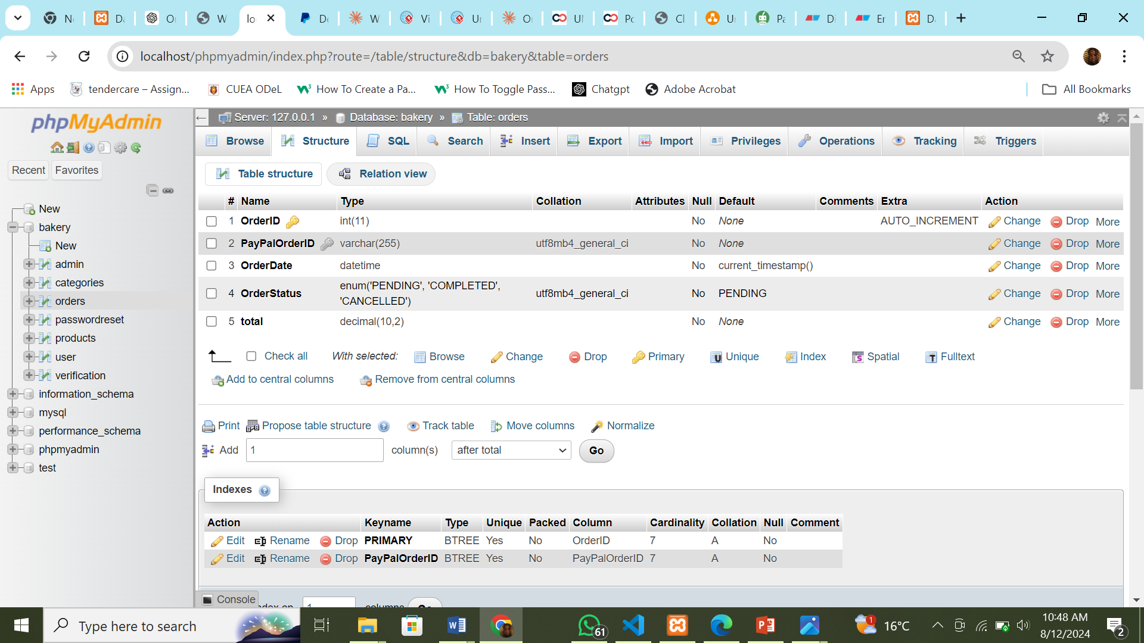

Figure 5.9: Orders Table

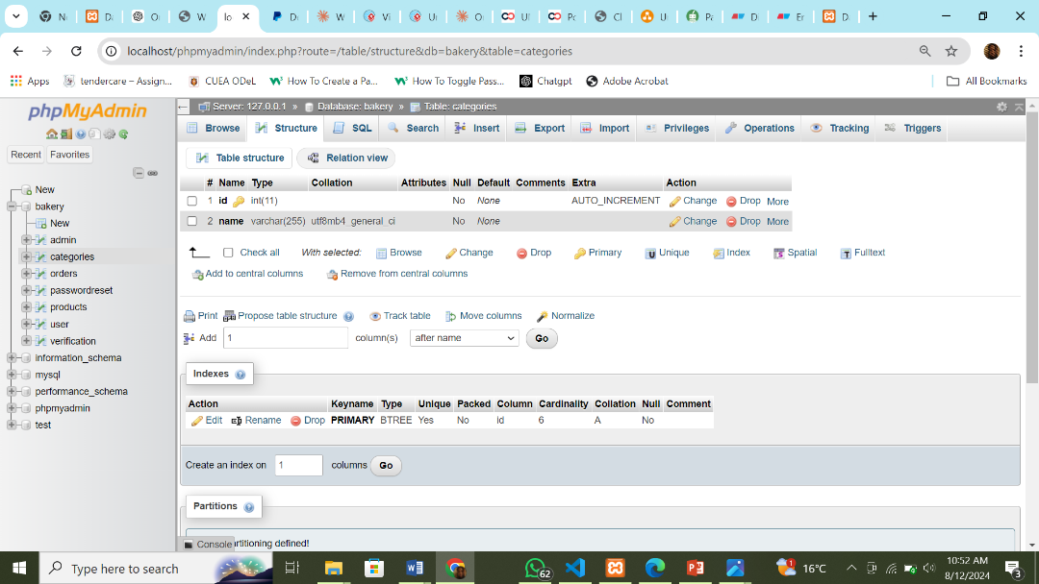

Figure 6.0: Categories Table

## 5.6 I/O of the Proposed System

The Input/ Output (I/O) section of the bakery management system defines how data is collected, processed, and output within the system. This section focuses on the mechanisms and procedures for handling input data from various users, such as customers, bakery staff, and administrators. It also covers how this data is processed through the system’s business logic and algorithms, and how the resulting outputs are generated and presented. In this section, we will explore the input and output functionalities of the proposed bakery management system, highlighting key aspects such as data entry methods, processing procedures, output formats, and user interaction mechanisms.

### 5.6.1 Authentication and Authorization

Authentication and authorization are critical components of the bakery management system, ensuring that only authorized users, such as bakery owners, staff, and customers, can access specific features and data within the system. A robust authentication mechanism is essential for maintaining the security and integrity of the system, safeguarding sensitive information like customer orders, payment details, and inventory data, and preventing unauthorized access.

In this section, we will explore the authentication and authorization design of the bakery management system, detailing the strategies and techniques employed to verify user identities, manage user credentials, and enforce access control. This includes:

1. **User Roles**

Different roles such as admin and customers, each with varying levels of access and permissions.

1. **Login Process**

Secure login procedures for users to authenticate themselves using usernames, passwords, and possibly two-factor authentication (2FA) for added security.

1. **Access Control**

Role-based access control (RBAC) to ensure that users only have access to the functionalities and data necessary for their role within the system.

1. **Session Management**

Techniques for managing user sessions securely, including session timeouts and secure cookie management.

This section will demonstrate how these authentication and authorization mechanisms are implemented to create a secure, user-friendly environment within the bakery management system, ensuring that all interactions are protected and compliant with best security practices.

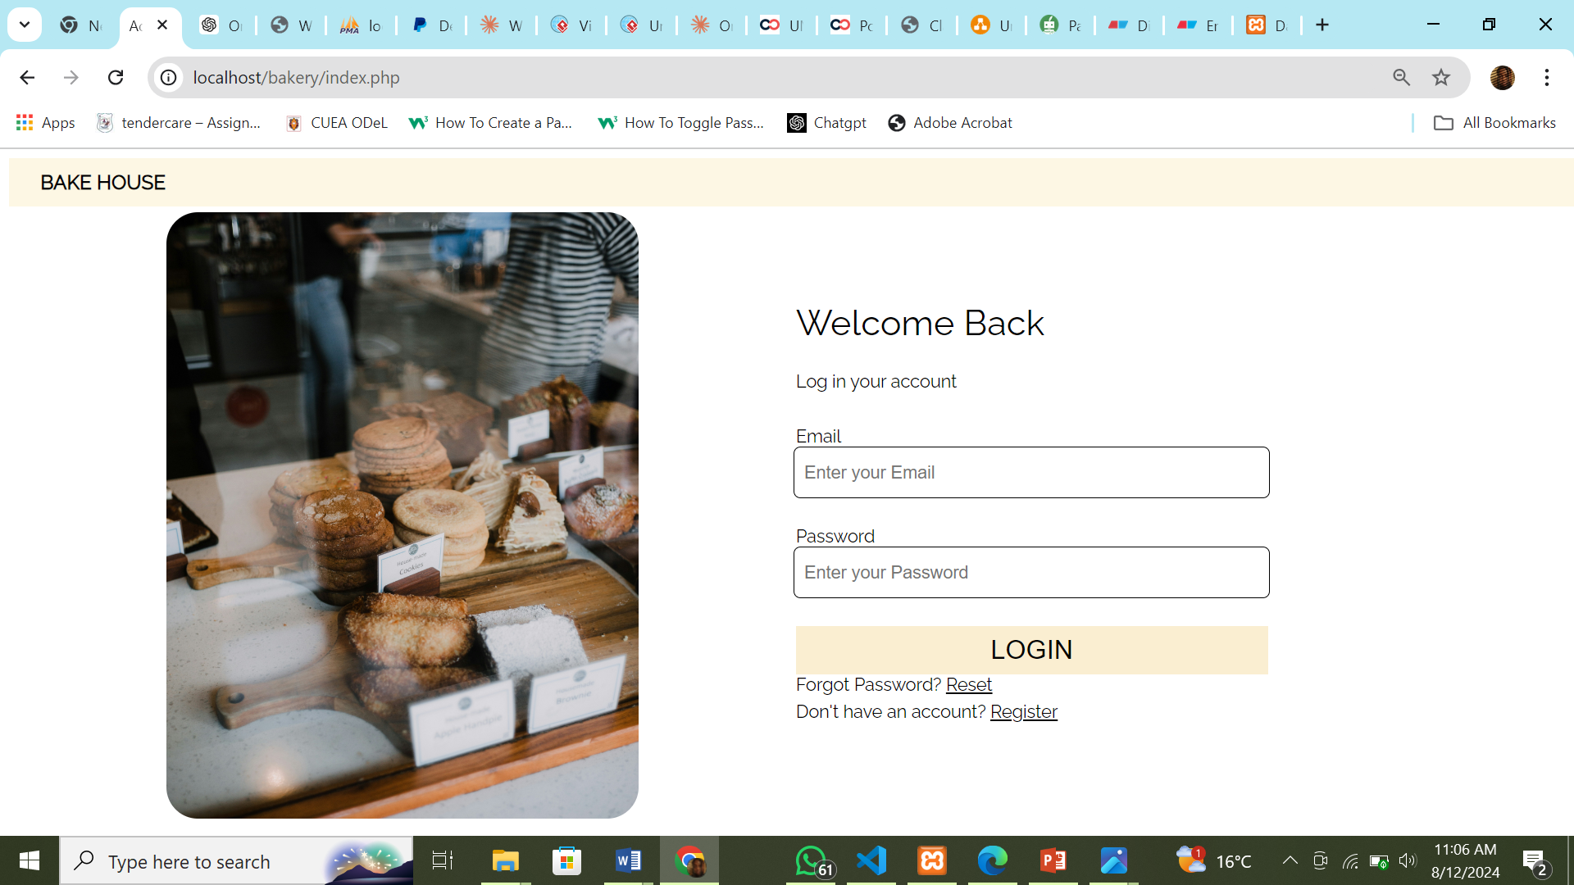

Figure 6.1: Proposed login page for client

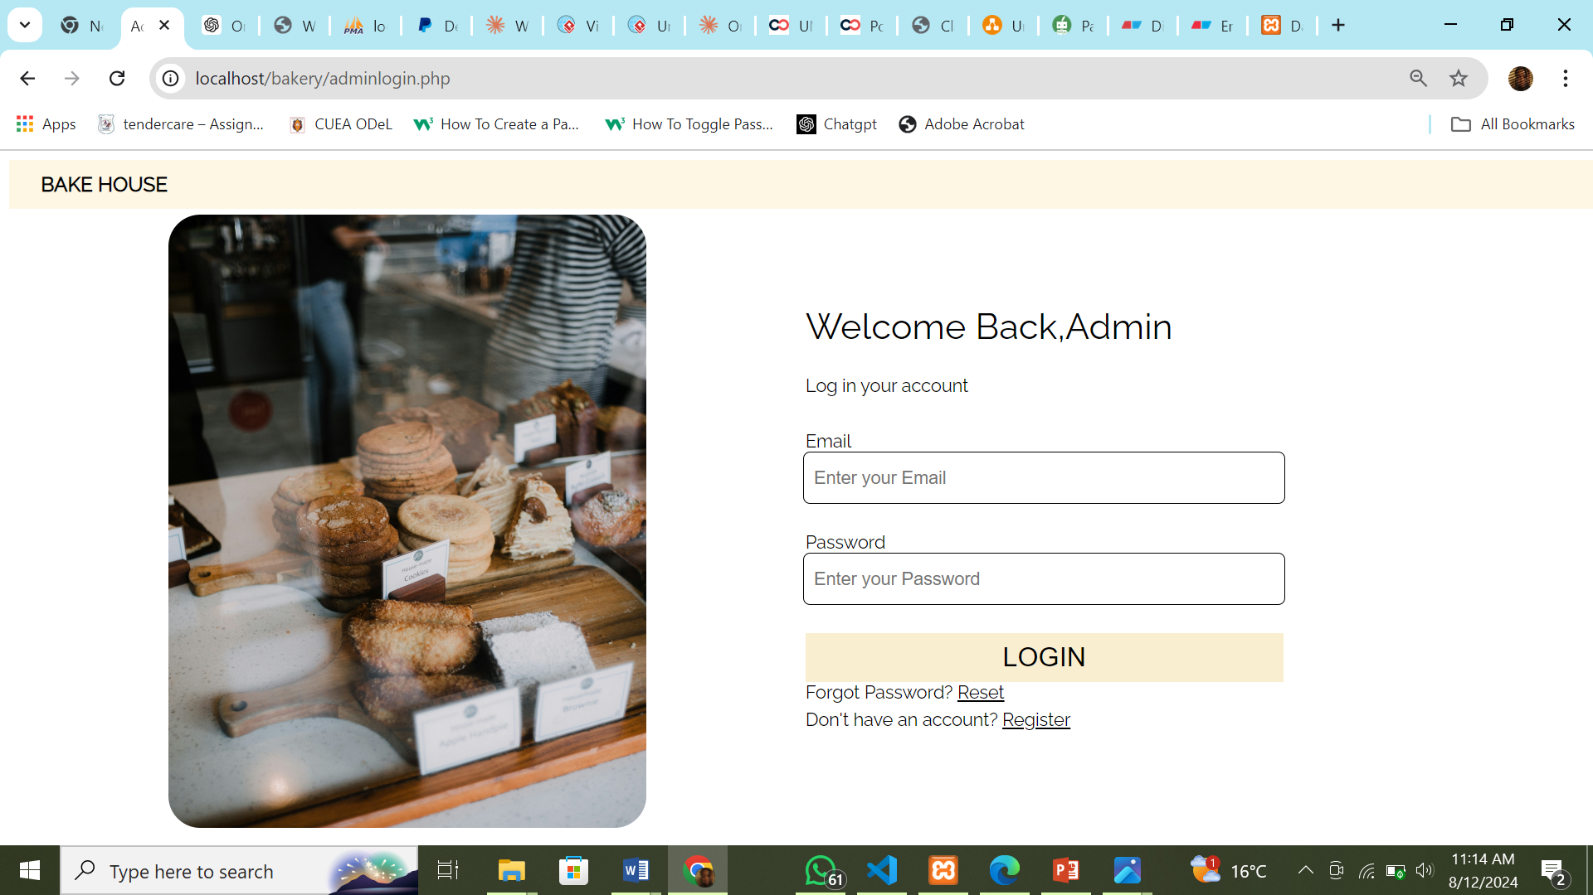

Figure 6.3: Proposed login for admin page

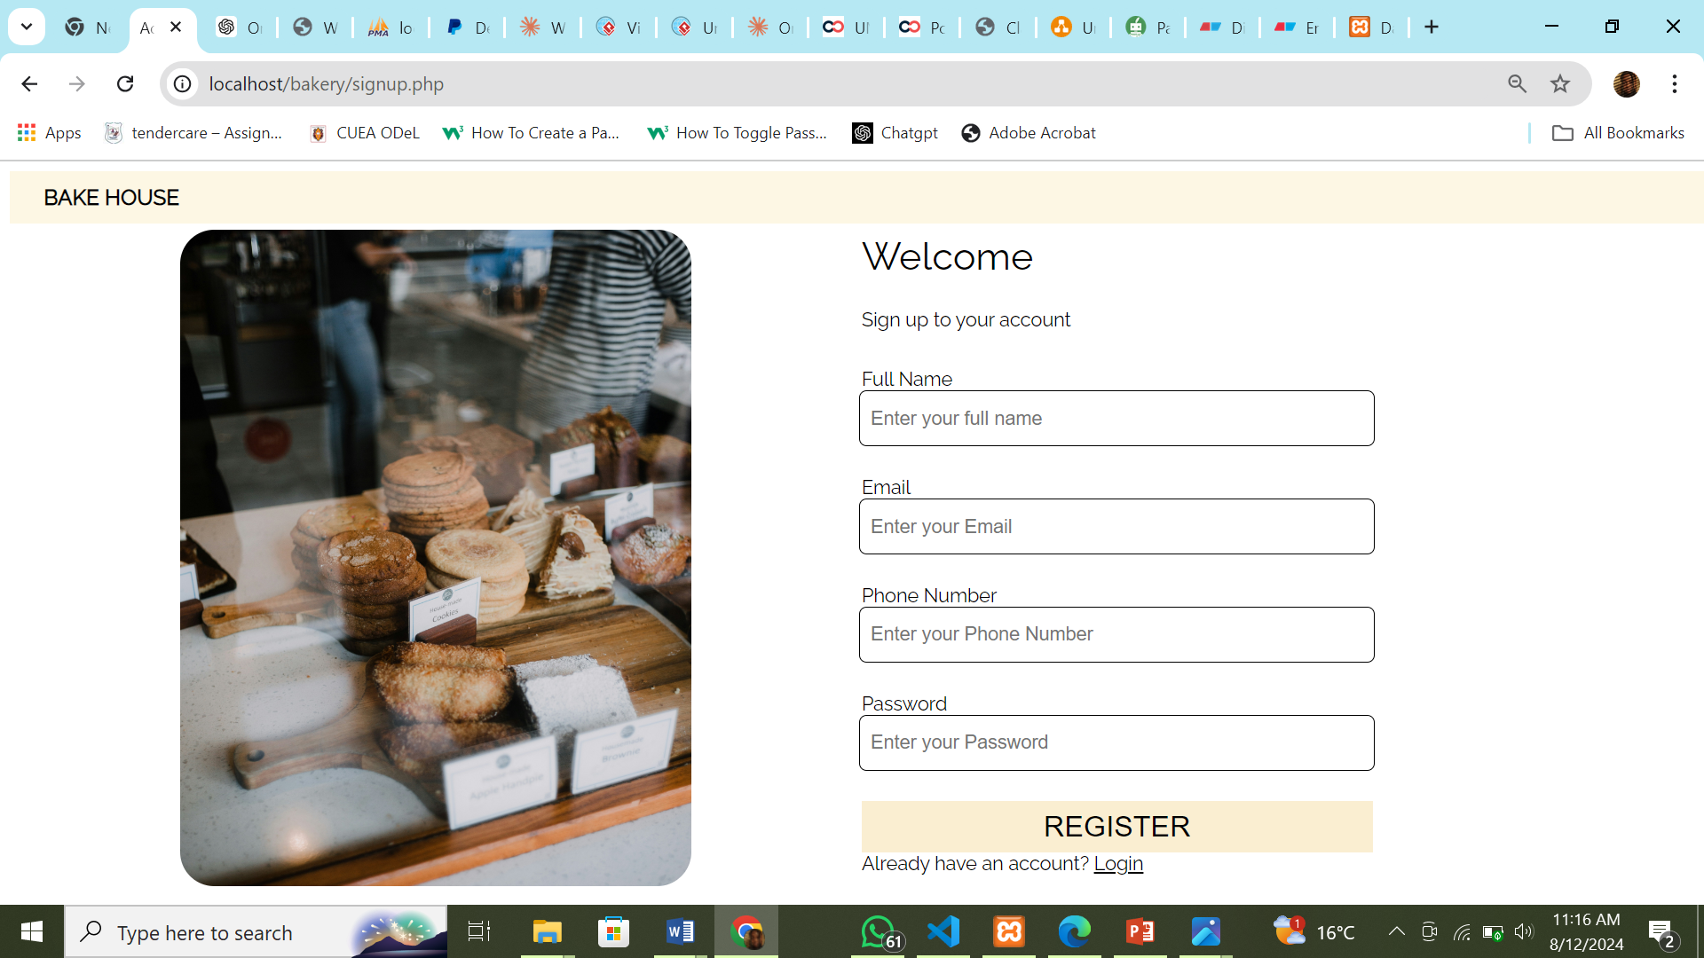

**Figure 6.4: Proposed signup page for client**

## 5.7 Test Data

The section on test data is crucial for ensuring the robustness and reliability of the bakery management system. To thoroughly test and validate the system's functionality, it is important to use a variety of test data that accurately represents real-world scenarios, including a diverse range of values and conditions. By incorporating test data that covers a wide spectrum of possible inputs—such as edge cases, outliers, and typical user interactions—the system can be rigorously evaluated for performance, accuracy, and resilience under different conditions.

This section will focus on the selection, generation, and utilization of test data to effectively simulate actual bakery management scenarios. Examples include testing with different types of orders (e.g., custom cakes, standard orders, small pastries), variations in customer preferences (e.g., Decoration Types, flavor choices), and edge cases like invalid payment methods or unexpected order volumes.

Through comprehensive testing using varied input scenarios, the system’s capabilities across multiple use cases and scenarios will be validated, ensuring that it performs reliably and meets the needs of bakery operations in real-world conditions.

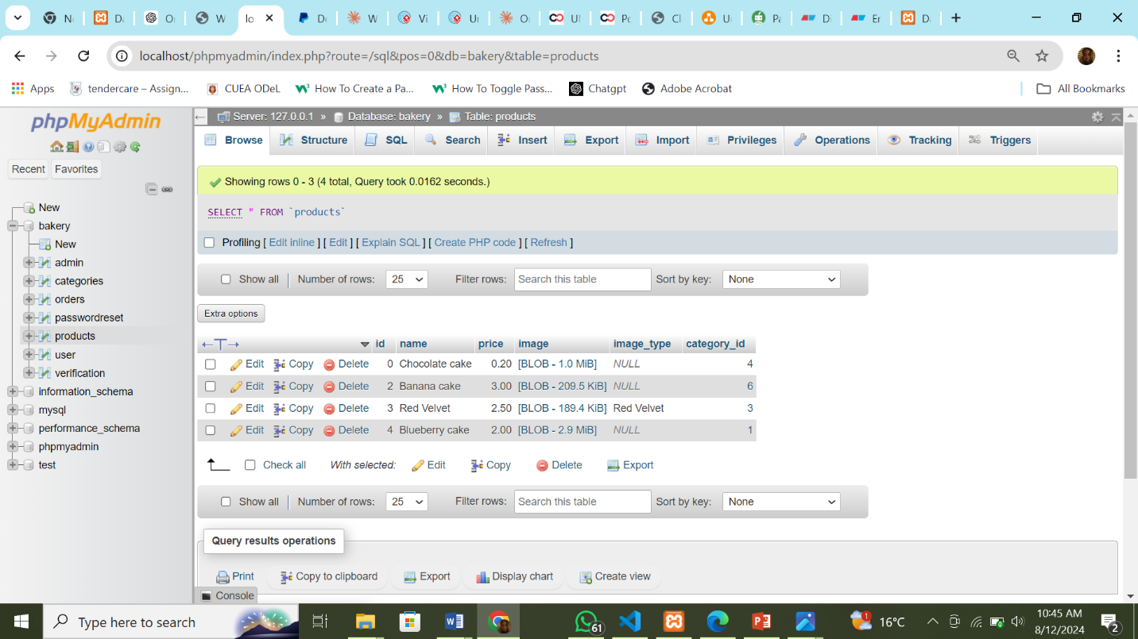

**Figure 6.5: Test data for products**

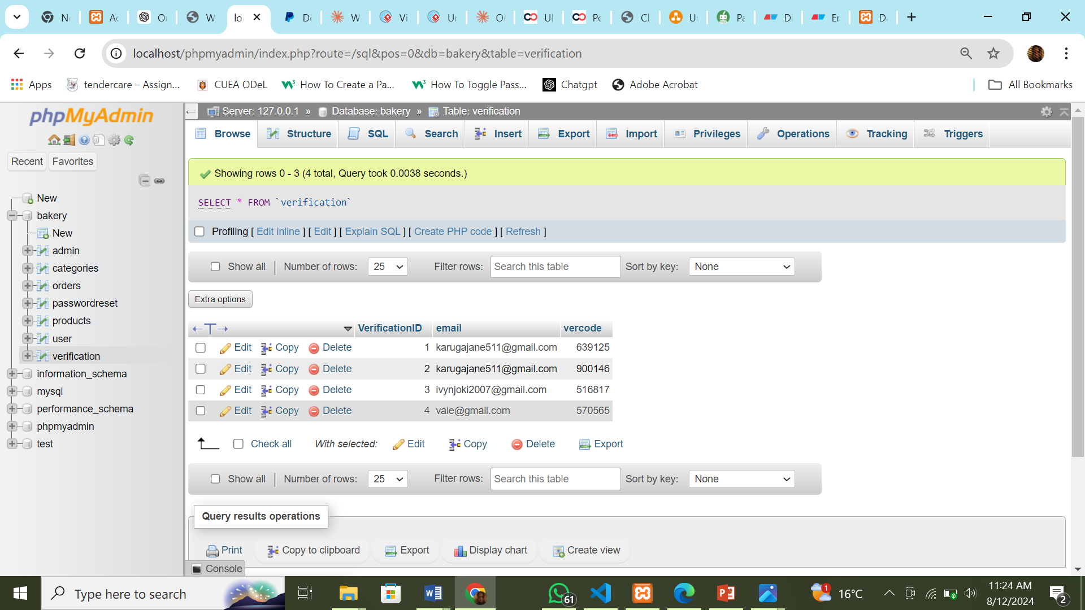

# Figure 6.6: Test data for verification code after login

## 5.8 Chapter Summary

This chapter presents a comprehensive overview of the system design for the proposed bakery management platform. It begins by describing the key features, strengths, and potential weaknesses of the system, setting the stage for the detailed design considerations that follow. The conceptual architecture is then outlined, highlighting the client-server model, three-tier structure (user interface, business logic, and data management), and the rationale behind the chosen design approach.

The chapter then delves into the process design, utilizing appropriate tools and techniques, such as flowcharts, data flow diagrams, activity diagrams, and sequence diagrams, to model the system's functionality. The database design is also covered, including the Entity-Relationship Diagram (ERD) and Data Dictionary, defining the data entities, relationships, and attributes relevant to bakery operations.

Additionally, the input/output design is presented, showcasing mock-up screens and describing the mechanisms for data entry, processing, and output generation, such as order placement, inventory management, and customer interaction. Finally, the chapter addresses the selection and generation of test data that adequately represents actual input scenarios, ensuring the system's robustness and ability to handle a diverse range of inputs typical of a bakery environment.

By covering these key aspects of system design, this chapter provides a comprehensive blueprint for the implementation and deployment of the proposed bakery management system.

# CHAPTER 6: SYSTEM IMPLEMENTATION

## 6.1 Chapter Introduction

This chapter focuses on the implementation and testing of the proposed bakery management system, translating the conceptual design into a functional and reliable application. It covers the development of the user interface, the implementation of the database design, the incorporation of key business processes, and the execution of module-level testing to ensure the system's overall quality and performance.

## 6.2 System Screenshots

The system’s implementation is visually represented through a series of screenshots, showcasing key functionalities and design aspects. These screenshots offer insights into various modules and interfaces within the system, providing a glimpse of the user experience and system architecture.

### 6.2.1 Clients Dashboard

The screenshot below shows the client's dashboard, where they are redirected immediately after logging in. It includes the following features:

**About Us Page:** Provides an overview of the bakery, including its mission, values, and history.

**Link to Custom Ordering:** Directs users to a page where they can place custom orders, allowing for personalized requests and specifications.

**Pictures of Popular Flavors:** Displays images of the bakery's most popular cake flavors, giving customers a visual preview of available options.

**Cart**: Allows users to view and manage products they’ve added for later checkout, including the ability to adjust quantities or remove items.

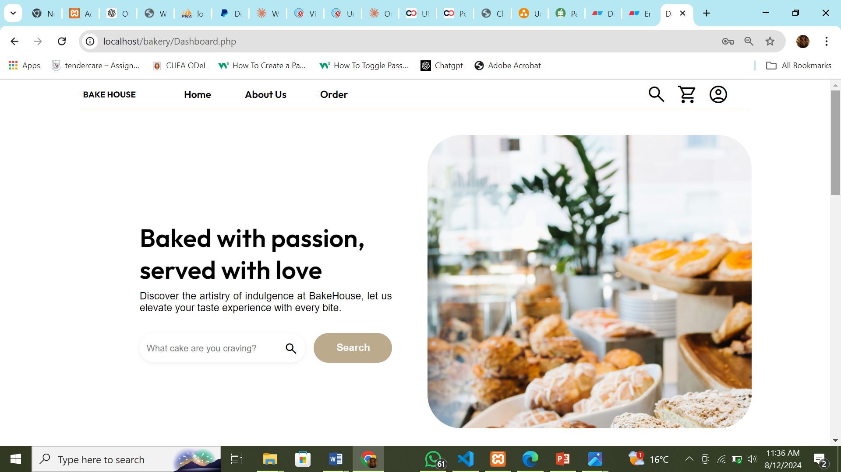

Figure 6.7: Proposed System landing page

### 6.2.2: Custom Order Page

This page is where customers can create customized orders for their bakery items. Key features include:

**Customization Options:** Users can select their preferred flavor, number of layers, toppings, and decorations to create a personalized cake or other bakery item.

**Preview Section:** A visual representation of the customizations is displayed, giving users a glimpse of their final product.

**Price Calculator:** As users make their selections, the total price updates dynamically to reflect the cost of each customization.

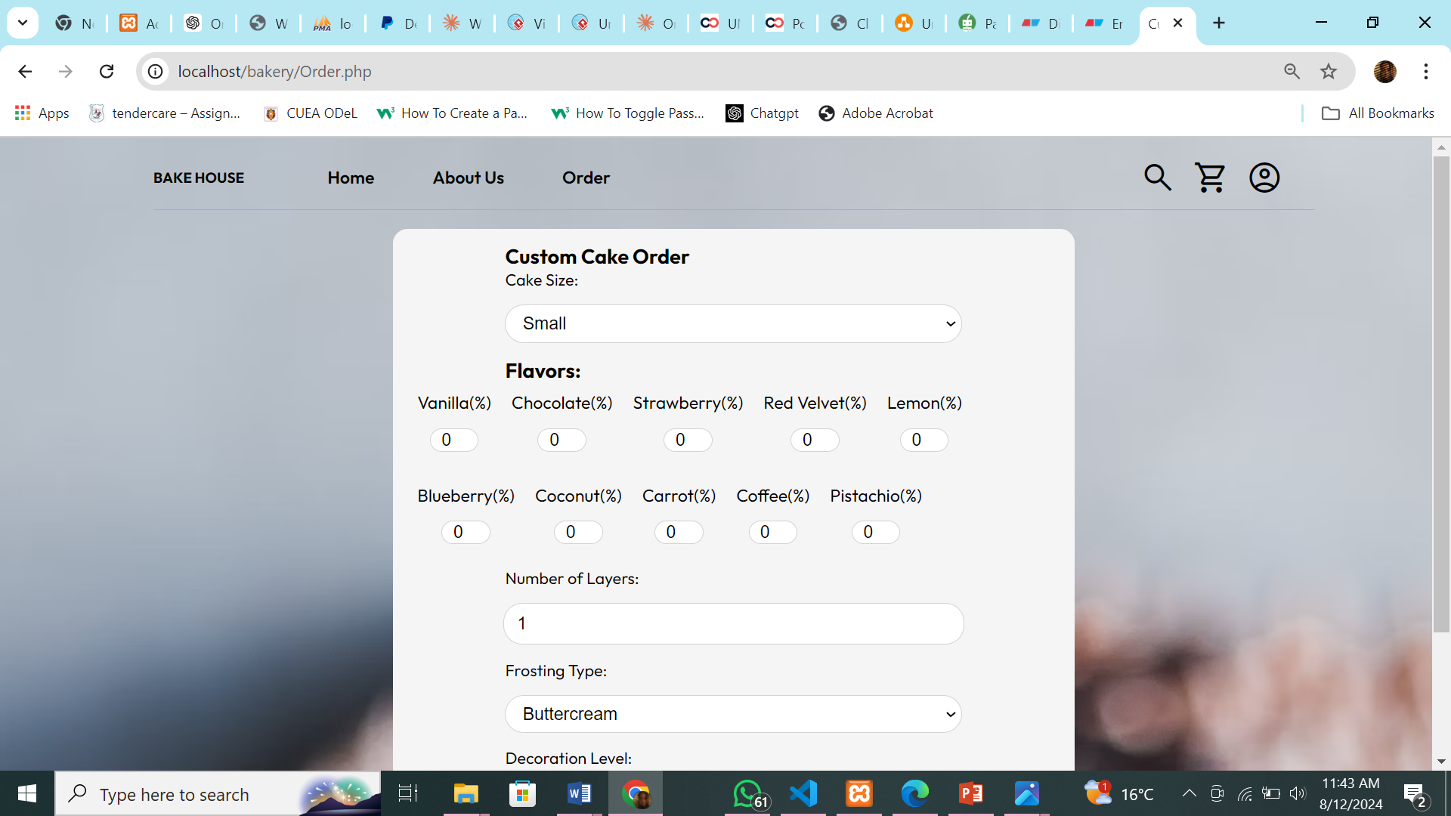

6.2.3: Gallery Page

The screenshot below shows the gallery page, where users can browse through a curated selection of cakes and baked goods. Key features:

**Image Grid:** The gallery displays high-quality images of available cakes, each visually representing the product's design, flavor, and decoration. Users can explore a variety of options tailored for different occasions.

**Add to Cart:** Users can add items to their cart directly by clicking on the photos of the products they wish to purchase, simplifying the shopping experience.

**Filter by Occasion:** The gallery includes a filtering option, allowing users to narrow down the selection based on the occasion, such as birthdays, weddings, or holidays, ensuring they find the perfect cake for their event.

# 

### **6.2.3:Clients Checkout Page**

The screenshot below shows the checkout page, where buyers finalize their purchases. Key features include:

**Cart Summary:** Provides a detailed summary of the items in the cart, including individual prices, quantities, and the option to adjust the number of items if needed.

**Shipping Address:** Users can enter or modify their delivery address to ensure accurate delivery of their order.

**Payment Options:** The checkout process supports payments through PayPal, offering a secure and convenient method for completing transactions.

**Order Total:** Displays the total cost of the order, including applicable taxes and shipping fees, providing a clear breakdown of the final amount to be paid.

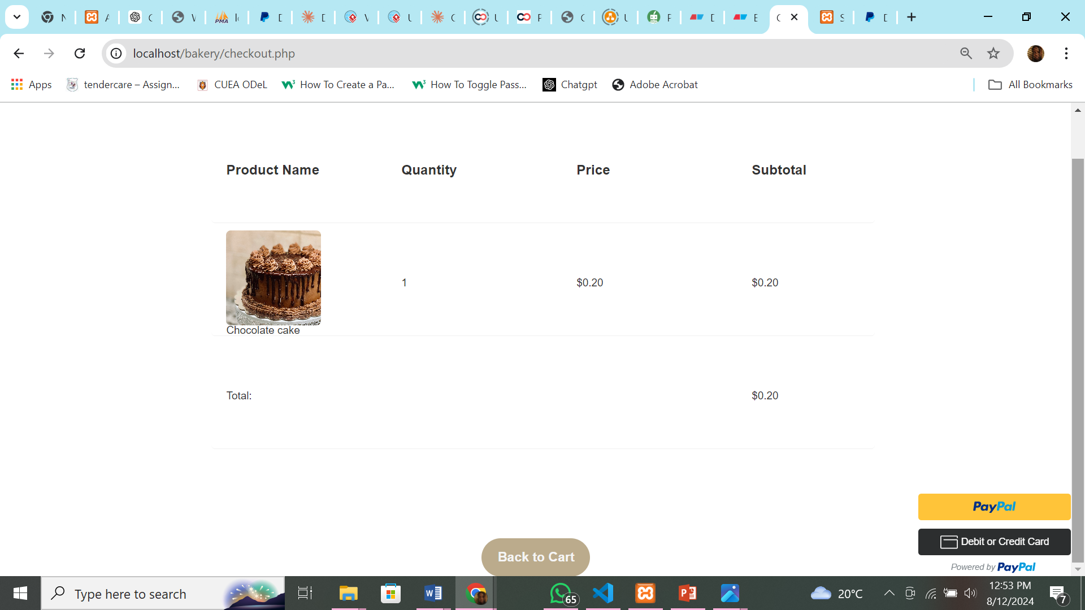

6.2.4: Clients Cart Page

The screenshot below displays the cart page where users review and manage their selected items before proceeding to checkout. Key features include:

**Cart Summary:** Shows a comprehensive list of items currently in the cart, including product names, quantities, unit prices, and the total price for each item. Users can modify quantities or remove items as needed.

**Order Total:** Calculates and displays the subtotal for all items, along with taxes and any applicable shipping fees, providing a clear overview of the total cost before finalizing the purchase.

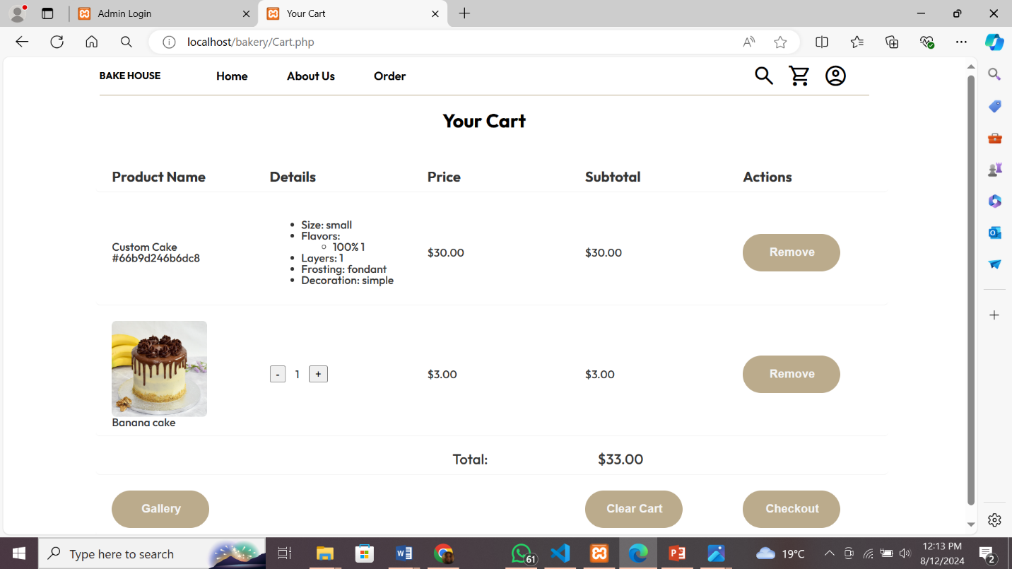

### Viewing Orders and Inventory (Admin):

The admin can access this page to manage various aspects of the bakery management system. Key features include:

**Order List:** Displays all orders placed by customers, including details such as order IDs, dates, and statuses.

**Order Details:** Provides comprehensive information about each order, including customer details, items purchased, and the current order status (e.g., pending, shipped, delivered).

**Customer Details:** Shows information about the customers, including their contact details and order history.

**Inventory Management:** Allows the admin to view and update the inventory, ensuring stock levels are accurate and products are available for sale.

**Add New Products:** Provides functionality for the admin to add new bakery products to the system, including product names, descriptions, prices, and images.

# 6.3 Testing Plan

The bakery management system requires a comprehensive testing plan to ensure all components function correctly and efficiently. The testing approach will encompass several key methods:

Unit Testing aims to verify that individual components of the bakery system, such as order processing, inventory management, and user account functionality, work as intended. Each module will be tested independently to ensure it operates correctly and meets specified requirements.

Integration Testing seeks to ensure that different modules of the bakery system work together seamlessly. Tests will be conducted to validate the interactions between order management, inventory updates, payment processing, and user interactions, ensuring smooth data flow and integration between components.

System Testing involves testing the complete bakery management system as a whole to confirm it meets the specified requirements. End-to-end testing will be performed, covering all functionalities from order placement to inventory updates and payment processing, to ensure the system operates as intended.

User Acceptance Testing (UAT) focuses on validating the bakery system’s functionality and usability from the end-user perspective. Various stakeholders such as customers, bakery staff, and administrators will test the system and provide feedback, helping identify any issues or areas for improvement to ensure the final product meets user needs and expectations.

## 6.4 Evaluation Plan

The evaluation plan outlines the criteria and methods used to assess the system’s performance, usability, and reliability.

Performance Evaluation focuses on measuring response time, transaction processing speed, and system uptime. Manual testing methods will be employed to simulate user load and measure the system's performance under various conditions. This evaluation helps ensure that the system can handle peak loads efficiently and remains responsive during high traffic periods.

Usability Evaluation aims to gauge user satisfaction, ease of navigation, and accessibility specific to the system. Tools such as user surveys, feedback forms, and usability testing sessions with representative users will be employed. This evaluation will gather insights into the user experience, identifying any pain points or areas for improvement to make the system more intuitive and user-friendly.

Reliability Evaluation mainly measures error rates, system crashes, and data integrity within the system. Monitoring tools will be utilized to track system errors and logs, ensuring data consistency and recovery capabilities. This evaluation ensures that the system is robust and reliable, capable of maintaining data integrity and recovering from potential failures without significant downtime.

These evaluation methods provide a comprehensive assessment of the bakery management system, ensuring it meets high standards of performance, usability, and reliability, thereby delivering a seamless experience for users.

## 6.5 Chapter Summary

This chapter focuses on the implementation of the proposed bakery management system. Visual representations via screenshots illustrate key functionalities such as client dashboards, custom order processes, cart management, and order and inventory management by the admin. The chapter also outlines a rigorous testing plan encompassing unit, integration, system, and user acceptance testing to ensure the system's reliability and performance. Additionally, an evaluation plan addresses performance, usability, and reliability, employing methods like manual testing for performance evaluation and usability testing for user satisfaction. This ensures the system meets high standards across all functional aspects, delivering an efficient and seamless user experience.

# CHAPTER 7: Conclusions, Findings & Recommendations

## 7.1 Introduction

This chapter summarizes the key findings, conclusions, and challenges encountered during the development and implementation of the bakery management system. It also provides recommendations for future improvements and enhancements to the system. The insights gained from this project are intended to guide future work and ensure the continued success and relevance of the system.

## 7.2 Conclusion

# The bakery management system has been successfully developed and implemented, providing a comprehensive platform for users to browse, customize, and manage bakery orders efficiently. The system's intuitive interface, robust functionality, and seamless integration of various modules have been well-received by users and administrators alike.

# The client dashboard offers a clear overview of popular cakes, custom ordering options, and a gallery of available products, allowing users to manage their activities with ease. The custom order page facilitates detailed customization based on flavor, layers, toppings, and decorations, while the cart and checkout processes enable smooth finalization of purchases.

# The testing and evaluation processes have confirmed that the system meets the specified requirements and performs reliably under different conditions. Unit testing ensured that individual components functioned as intended, while integration testing validated the seamless interaction between different modules. System testing confirmed that the entire system operates smoothly, and user acceptance testing (UAT) provided valuable feedback to enhance the system's usability and functionality.

# The project's objectives of streamlining the bakery ordering process and enhancing user satisfaction have been achieved. The system's ability to provide a one-stop solution for bakery orders has been particularly appreciated, as it eliminates the need for users to navigate multiple platforms and vendors.

# In addition to simplifying the ordering process, the system has also improved user satisfaction by offering personalized and customizable options. Users can tailor their orders based on individual preferences, and the system's advanced search and filter options make it easy to find and select the desired products. The secure checkout process has also been well-received, providing a transparent and reliable way to handle transactions.

# Furthermore, the system has proven to be scalable and adaptable, capable of handling increased user load and incorporating new features based on user feedback. This flexibility ensures that the system can evolve to meet the changing needs of users and continue to provide a valuable service in the future.

# Overall, the bakery management system has delivered on its promise of providing a streamlined, efficient, and user-friendly platform for bakery orders. By addressing key pain points in the ordering process and offering a comprehensive solution, the system has successfully enhanced the user experience and positioned itself as a valuable tool in the bakery industry.

## 7.3 Challenges Encountered

# During the development and implementation phases, several challenges were encountered that required careful consideration and resolution to ensure the success of the bakery management system.

# One of the primary challenges was ensuring seamless integration between different modules, such as the custom ordering system, inventory management, and user dashboard. Each of these modules needed to communicate effectively with one another to provide a cohesive user experience. This required extensive testing and debugging to ensure smooth data flow and functionality. Integrating third-party services, particularly payment gateways, added an extra layer of complexity, involving coordination with external APIs and ensuring secure and accurate transaction data handling.

# Maintaining data integrity and security was another significant challenge, especially during transactions. Given the sensitive nature of personal and financial information processed by the system, implementing robust security measures was paramount. This included encrypting data both in transit and at rest, enforcing strict access controls, and conducting regular security audits to identify and mitigate potential vulnerabilities. Compliance with data protection regulations required careful planning and implementation of privacy policies and user consent mechanisms.

# Gathering and incorporating user feedback to enhance usability posed a challenge that necessitated iterative design and development cycles. Engaging with a diverse group of users to obtain comprehensive feedback was crucial for identifying usability issues and areas for improvement. Balancing user feedback with the project timeline and resource constraints was often challenging. Iterative development allowed the team to address user concerns incrementally, but it required flexibility and effective project management to ensure that enhancements were implemented without disrupting the overall development process.

# Additionally, ensuring the system's scalability and performance under varying loads was a challenge that required meticulous planning and testing. The system needed to handle a large number of simultaneous users, especially during peak times such as holiday seasons. Load testing and performance optimization were essential to ensure that the system remained responsive and reliable under high traffic conditions. This involved optimizing database queries, implementing efficient caching strategies, and leveraging robust infrastructure to scale resources dynamically.

# Overall, while these challenges were significant, they were effectively addressed through thorough planning, testing, and iterative development. Overcoming these obstacles contributed to the creation of a robust, secure, and user-friendly bakery management system that successfully meets the needs of its users.

## 7.4 Future Recommendations

# Based on the findings and experiences from this project, the following recommendations are proposed:

# Enhanced Personalization: Implement advanced personalization features that tailor the user experience based on individual preferences and past interactions. This could include personalized product recommendations, customized dashboards, and more.

# Mobile App Development: Develop a mobile application to complement the web-based system. A mobile app would offer greater accessibility and convenience, allowing users to manage their bakery orders on the go.

**Enhanced Search and Filtering Options**: Improve the search functionality to include more detailed filtering options based on ingredients, dietary preferences, and price ranges. This will help users find specific bakery products that meet their needs more efficiently.

**Real-Time Inventory Updates:** Implement real-time inventory tracking to ensure that product availability is accurately reflected. This feature can help prevent overselling and improve customer satisfaction by providing up-to-date information on stock levels.

**Integration with Delivery Services**: Integrate with local or national delivery services to streamline the delivery process. This could include real-time tracking of orders and automated delivery scheduling, enhancing the customer experience and operational efficiency.

# 

# REFERENCES

Alam, M. M., Islam, M. R., & Alam, M. J. (2019). Implementation of an E-bakery management system: A case study in Bangladesh. Journal of Engineering and Applied Sciences, 14(10), 3341-3348.

Al-Hinai, H. A., & Al-Qatab, R. M. (2018). E-commerce adoption in small and medium enterprises (SMEs) in developing countries: A systematic review of literature. Journal of Entrepreneurship, Management and Innovation, 14(2), 65-89. doi: 10.7341/20181426

Bhatti, R. A., & Kamal, M. A. (2019). Web-based e-bakery management system. In 2019 3rd International Conference on Computing and Networking (CANDAR) (pp. 383-388). IEEE.

Brown, R., & Miller, S. (2020). User-Centric Design Approaches for E-Bakery Management Systems. International Journal of Human-Computer Interaction, 36(11), 1033-1044. doi:10.1080/10447318.2020.1756548

Cohen, J. (2022). The Rise of Sustainability: Implications for Businesses and Consumer Behavior. Harvard Business Review, 88(1), 78-91.

Deloitte. (2022). Sustainability in Consumer Behavior: A Three-Year Study. Retrieved from <https://www2.deloitte.com/sustainabilityconsumerbehavior2022>.

Evans, L., & Smith, J. (2020). Optimizing User Experience in E-Bakery Management Platforms. International Journal of User Experience Research, 12(4), 65-74. doi:10.1177/1094342020933407

Gheorghe, M., Popescu, D., Trandabat, D., & Gheorghe, L. (2017). Importance of System Design in Software Development Life Cycle. Procedia Engineering, 181, 284-289.

Goyal, S., Gupta, S., & Aggarwal, S. (2018). Implementation of web-based e-bakery management system in a bakery in India: A case study. International Journal of Applied Engineering Research, 13(23), 16824-16830.

Grand View Research. (2021). Bakery products market size, share & trends analysis report by product (bread, breakfast cereals, cakes & pastries, biscuits), by distribution channel (offline, online), by region, and segment forecasts, 2021-2028. Retrieved from <https://www.grandviewresearch.com/industry-analysis/bakery-products-market>

Harris, T., & Roberts, P. (2019). Streamlining Order Fulfillment in E-Bakery Platforms. Journal of E-Business and E-Commerce, 14(1), 45-54. doi:10.1080/15427460903175424

Hoffer, J.A., George, J.F., & Valacich, J.S. (2014). Modern Systems Analysis and Design, 8th Edition. Pearson.

Hu, X., Huang, C., & Fang, M. (2018). Research on e-bakery management system of small and medium-sized enterprises. In 2018 2nd International Conference on Management Science and Management Innovation (MSMI 2018) (pp. 128-132). Atlantis Press.

Jackson, R., & Turner, A. (2022). Integrating Social Media with E-Bakery Management Systems. Journal of Digital Marketing and Social Media, 17(2), 78-89. doi:10.1177/17553387211016534

Kapoor, K. K., Dwivedi, Y. K., & Williams, M. D. (2016). From information management to information governance: New opportunities and challenges. Journal of Information Science, 42(1), 1-17. doi: 10.1177/0165551515594563

Kulkarni, S., & Deshpande, S. (2017). An empirical study of e-commerce adoption in Indian bakery industry. International Journal of Advanced Research in Computer Science, 8(5), 745-752.

Lee, C., & Kim, H. (2020). Enhancing E-Bakery Systems Through Machine Learning Techniques. International Journal of Artificial Intelligence and Machine Learning, 8(6), 58-67. doi:10.1080/20796804.2020.1765174

Lopez, M., & Fernandez, J. (2021). Developing an E-Bakery System with Real-Time Order Tracking and Management. Journal of Online Retail and E-Commerce, 16(2), 77-86. doi:10.1016/j.jretai.2021.02.003

Miller, D., & Zhang, L. (2022). Implementing Real-Time Analytics in Online Bakery Management Systems. Journal of Data Analysis and Management, 10(2), 89-101. doi:10.1007/s10766-021-00324-4

Murray, C., & Langlois, G. (2013). Developing a bakery management system. In 2013 IEEE Global Engineering Education Conference (EDUCON) (pp. 372-378). IEEE.

Nguyen, T., & Nguyen, H. (2021). Security Measures for Online Bakery Management Systems. Journal of Cyber Security and Privacy, 6(3), 123-135. doi:10.1002/cem.2330

Santos, J., & Oliveira, P. (2021). Automating Inventory and Supply Chain in E-Bakery Platforms. Journal of Business Logistics, 42(3), 192-204. doi:10.1111/jbl.12234

Singh, A. (2022). Shifting Consumer Behavior towards Eco-friendly Purchasing: Implications for the Retail Industry. Journal of Sustainable Business, 12(3), 45-58.

Statista. (2021). Global bakery market size 2018-2024. Retrieved from <https://www.statista.com/statistics/804974/bakery-market-size-worldwide>

Williams, M., & Garcia, E. (2019). E-Bakery Systems and Their Impact on Customer Satisfaction. Journal of Service Management, 30(4), 439-457. doi:10.1108/JOSM-02-2019-0072

Yildirim, K. (2020). A systematic review of e-bakery management systems. Computers in Industry, 120, 103311.

# APPENDICES

# APPENDIX A:SAMPLE QUESTIONNAIRE

Online Bakery Management System Questionnaire: To provide an understanding of the use of bakery management systems and evaluate its impact on customers

**BIODATA**

Please fill in the spaces below marked with asterisks (*) before beginning the questionnaire.

*Kindly specify your gender: _____________________

*What age are you currently: _____________________

*How long have you been a customer here? (Indicate First Time for new customers): _____________

**INSTRUCTIONS**Please answer the following questions in the spaces provided by ticking where it may apply for you. Thank you

1. How frequently do you visit our shop for purchases?

Daily

Weekly

Monthly

Rarely

Never

1. Have you ever experienced any inconvenience while purchasing from our shop

Yes

No

1. How likely are you to use a website for purchasing baked goods?

Very likely

Somewhat likely

Neutral

Somewhat unlikely

Very unlikely

1. What features would you expect from our website?
   * + Online ordering
     + Delivery tracking
     + Customized orders
     + Loyalty programs
     + Discounts and coupon
     + Others (please specify)
2. How important is it for you to be able to track your order status and delivery?

* Very important
* Somewhat important
* Neutral
* Not very important
* Not important at all

6. How satisfied are you with the quality of the baked goods you receive from the bakery?

* Very satisfied
* Somewhat satisfied
* Neutral
* Somewhat dissatisfied
* Very dissatisfied

1. Is there anything else you would like to share about your experience with our website or suggestions for improvement? Please feel free to write down your answer. _____________________________________________________________________________________________________________________________________________________________________________________________________________________

## APPENDIX B: PROJECT BUDGET

The project budget outlines the funds allocated for several research components, including development, infrastructure, software tools, marketing, equipment maintenance, internet, and backup. It provides a clear image of the projected cost, which aids in effective money management and planning throughout the project. The project budget that follows details the amount allocated to each cost category, ensuring that the funds are utilized effectively to support the objectives of the research.

|  |  |
| --- | --- |
| **EXPENSES** | **COST (Kshs)** |
| Laptop | 50,000 |
| Printing | 5,000 |
| Transport | 3,500 |
| Airtime | 2,500 |
| Internet (Wi-Fi) | 3,000 |
| Miscellaneous(5% of the budget) | 5,000 |
| **Total Cost:** | **67,200** |

## APPENDIX C: PROJECT SCHEDULE

This outlines the different stages, activities, and schedules necessary to ensure the effective development and deployment of the online bakery management system.Top of Form

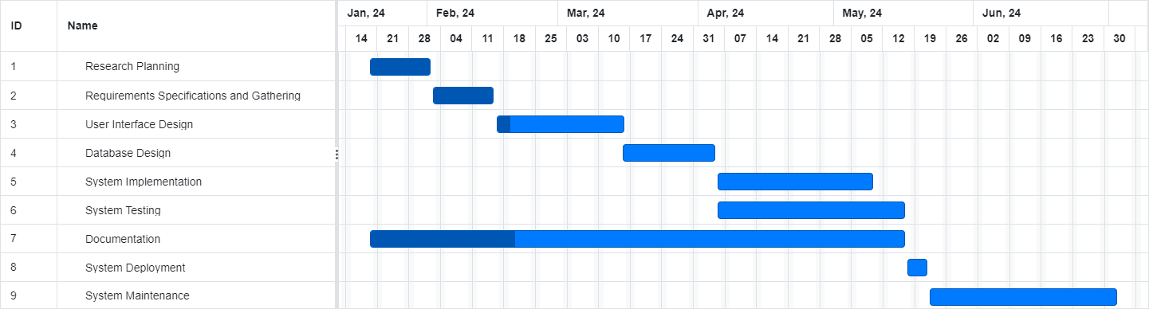

## APPENDIX D:SAMPLE CODE

